**TOURISM MONITORING SYSTEM FOR BOLINAO**

A Project Study Presented to the Faculty of

Information Technology Department

Pangasinan State University

Alaminos City Campus

In Partial Fulfillment

Of the Requirements of the Degree

BACHELOR OF SCIENCE IN INFORMATION TECHNOLOGY

by:

DANILYN V. BANOGON

JESTER EINSTEIN C. IBASAN

JERHOME T. REANTASO

JASMINE B. ZINAMPAN

December 2022

# APPROVAL SHEET

This project study entitled TOURISM MONITORING SYSTEM FOR BOLINAO prepared and submitted by DANILYN V. BANOGON, JESTER EINSTEIN C. IBASAN, JERHOME T. REANTASO and JASMINE B. ZINAMPAN, in partial fulfillment of the requirements for the degree of BACHELOR OF SCIENCE IN INFORMATIONTECHNOLOGY, has been examined and is recommended for acceptance and approval for oral examination.

__________________________

CHRISTIAN PAUL O. CRUZ

Adviser

PROJECT STUDY COMMITTEE

___________________

D’ALCHEMY O. MONES

Chairman

____________________ __________________________________ RUISSAN A. RAMOS, MIT  CARLO GENSTER P. CAMPOSAGRADO, MIT

Member Member

PANEL EXAMINERS

APPROVED by the Committee on Oral Examination on

___________________ with the grade of ______________.

___________________

D’ALCHEMY O. MONES

Chairman

____________________ __________________________________ RUISSAN A. RAMOS, MIT CARLO GENSTER P. CAMPOSAGRADO, MIT

Member Member

ACCEPTED AND APPROVED in partial fulfillment of the requirements for the degree of BACHELOR OF SCIENCE IN INFORMATION TECHNOLOGY.

__________________ __    _____________________

RUISSAN A. RAMOS, MIT     JENYLYN V. OBOZA, PhD

Department Chairperson Campus Executive Director

Information Technology     Alaminos City Campus

**ACKNOWLEDGEMENT**

The proponents would like to thank Almighty God for providing them with the strength, guidance, knowledge, and good health to make the proposed system a reality.

This would not be possible without the unending support and guidance of those who paved the way for the proponents to create results for the proposed system.

The proponents would like to thank Ruissan A. Ramos for patiently teaching and sharing his ideas for the study's development, as well as for the encouragement to work hard to complete their project.

To the advisor, Sir Christian Paul O. Cruz, who devotes his time and assistance to guiding the proponents throughout the conducting of the study.

To the members of the oral defense panel, who improved their study, for their brilliant comments and suggestions.

To their parents and guardians, who always provide unconditional emotional, mental, spiritual, and financial support, as well as unending care and love.

To their friends and classmates who shared their knowledge regarding to our study.

The Proponents

**Abstract**

Tourism Monitoring System for Bolinao

Danilyn V. Banogon, Jester Einstein C. Ibasan, Jerhome T. Reantaso, and Jasmine B. Zinampan, of Bachelor of S Science in Information Technology, Pangasinan State University - Alaminos City Campus.

People continue to transition to the technology offered by the digital world. The transition to manual process to online process is evident because of the COVID-19 pandemic. Although tourism was halted prior to the pandemic, it continues to recover again together with new applications based on technology of the current era.

This study discusses the development of Tourism Monitoring System for Bolinao where it aims to provide an online platform for Bolinao Tourism to monitor tourism activities. The proponents used the Scrum Methodology in the development of the web system. Descriptive research was utilized along with the implementation of the proponents with collaborative tools. Existing process in the workflow of Bolinao Tourism was described and problems were stated. This produced backlogs that were devised to implement features that provides solution.

Tourism Monitoring System has garnered positive feedback to the tourism office and end-users. The acceptability assessment has shown that the tourism office and end-users are satisfied with the features and function of the web-application. Further studies must be conducted to enhance the features of the web-application.

# TABLE OF CONTENTS

Page

Title Page 1

APPROVAL SHEET 2

Acknowledgement 3

Abstract 4

TABLE OF CONTENTS 5

LIST OF FIGURES 8

LIST OF TABLES 10

CHAPTER

1 INTRODUCTION

Situational Analysis 11

Objectives of the Study 17

Importance of the Study 18

Scope and Delimitation 19

Definition of Terms 20

2 METHODOLOGY

Project Framework 22

Project Design 24

Population and Locale of the Study 32

Data Instrumentation 34

Tools for Data Analysis 35

Tools for System Development 38

Description of Initial Prototype 41

The Proposed Implementation Plan 45

3 RESULTS AND DISCUSSION

Current Process in Tourism Office System 48

Difficulties Encountered in the Current System of Tourism Office 52

Features of the Proposed System 54

Acceptability Test of the Proposed System 63

4 SUMMARY, CONCLUSIONS, AND RECOMMENDATIONS

Summary 70

Conclusions 71

Recommendations 73

REFERENCES 74

APPENDICES

A Gantt Chart 78

B Workplan 79

C Letter to Conduct Studies 80

D Interview Guide 81

E Use Case Diagram 82

F Use Case Description 85

G Entity Relationship Diagram 92

H Data Dictionary 93

I Acceptability Questionnaire 99

J Tabulation of Results 101

K List of Registered Establishments 103

l Documentation 109

m Certificate of Grammar Check 117

Curriculum Vitae 118

# LIST OF FIGURES

Figure No. Title Page

[1 Scrum Model 25](https://psueduph1-my.sharepoint.com/personal/19ac0535_ms_psu_edu_ph/Documents/CAPSTONE-TRELLO/MANUSCRIPT-V4.docx#_Toc105261427)

[2 Initial Landing Page 41](https://psueduph1-my.sharepoint.com/personal/19ac0535_ms_psu_edu_ph/Documents/CAPSTONE-TRELLO/MANUSCRIPT-V4.docx#_Toc105261428)

[3 Initial Login Page 42](https://psueduph1-my.sharepoint.com/personal/19ac0535_ms_psu_edu_ph/Documents/CAPSTONE-TRELLO/MANUSCRIPT-V4.docx#_Toc105261429)

[4 Initial Dashboard](https://psueduph1-my.sharepoint.com/personal/19ac0535_ms_psu_edu_ph/Documents/CAPSTONE-TRELLO/MANUSCRIPT-V4.docx#_Toc105261430) 43

[5 Initial Booking Page 43](https://psueduph1-my.sharepoint.com/personal/19ac0535_ms_psu_edu_ph/Documents/CAPSTONE-TRELLO/MANUSCRIPT-V4.docx#_Toc105261431)

[6 Initial Map 44](https://psueduph1-my.sharepoint.com/personal/19ac0535_ms_psu_edu_ph/Documents/CAPSTONE-TRELLO/MANUSCRIPT-V4.docx#_Toc105261432)

[7 Full-screen Map 45](https://psueduph1-my.sharepoint.com/personal/19ac0535_ms_psu_edu_ph/Documents/CAPSTONE-TRELLO/MANUSCRIPT-V4.docx#_Toc105261433)

[8 Registration of Tourists’ Data 49](https://psueduph1-my.sharepoint.com/personal/19ac0535_ms_psu_edu_ph/Documents/CAPSTONE-TRELLO/MANUSCRIPT-V4.docx#_Toc105261432)

[9 Collecting Tourist Data Manually 50](https://psueduph1-my.sharepoint.com/personal/19ac0535_ms_psu_edu_ph/Documents/CAPSTONE-TRELLO/MANUSCRIPT-V4.docx#_Toc105261432)

[10 Tourist Data Collection through Google Forms 51](https://psueduph1-my.sharepoint.com/personal/19ac0535_ms_psu_edu_ph/Documents/CAPSTONE-TRELLO/MANUSCRIPT-V4.docx#_Toc105261432)

[11 Encoding of Data in Excel 52](https://psueduph1-my.sharepoint.com/personal/19ac0535_ms_psu_edu_ph/Documents/CAPSTONE-TRELLO/MANUSCRIPT-V4.docx#_Toc105261432)

[12 Register Account 54](https://psueduph1-my.sharepoint.com/personal/19ac0535_ms_psu_edu_ph/Documents/CAPSTONE-TRELLO/MANUSCRIPT-V4.docx#_Toc105261432)

[13 User Profile Setting 55](https://psueduph1-my.sharepoint.com/personal/19ac0535_ms_psu_edu_ph/Documents/CAPSTONE-TRELLO/MANUSCRIPT-V4.docx#_Toc105261432)

[14 Dashboard 56](https://psueduph1-my.sharepoint.com/personal/19ac0535_ms_psu_edu_ph/Documents/CAPSTONE-TRELLO/MANUSCRIPT-V4.docx#_Toc105261432)

[15 Live Map Counter 56](https://psueduph1-my.sharepoint.com/personal/19ac0535_ms_psu_edu_ph/Documents/CAPSTONE-TRELLO/MANUSCRIPT-V4.docx#_Toc105261432)

[16 Booking – User Info 57](https://psueduph1-my.sharepoint.com/personal/19ac0535_ms_psu_edu_ph/Documents/CAPSTONE-TRELLO/MANUSCRIPT-V4.docx#_Toc105261432)

[17 Booking – Additional Information 58](https://psueduph1-my.sharepoint.com/personal/19ac0535_ms_psu_edu_ph/Documents/CAPSTONE-TRELLO/MANUSCRIPT-V4.docx#_Toc105261432)

[18 Booking – Generate Ticket Number 59](https://psueduph1-my.sharepoint.com/personal/19ac0535_ms_psu_edu_ph/Documents/CAPSTONE-TRELLO/MANUSCRIPT-V4.docx#_Toc105261432)

[19 Request Logs 59](https://psueduph1-my.sharepoint.com/personal/19ac0535_ms_psu_edu_ph/Documents/CAPSTONE-TRELLO/MANUSCRIPT-V4.docx#_Toc105261432)

[20 Adding Site Location in Live Map 60](https://psueduph1-my.sharepoint.com/personal/19ac0535_ms_psu_edu_ph/Documents/CAPSTONE-TRELLO/MANUSCRIPT-V4.docx#_Toc105261432)

[21 Staff Account Creation 61](https://psueduph1-my.sharepoint.com/personal/19ac0535_ms_psu_edu_ph/Documents/CAPSTONE-TRELLO/MANUSCRIPT-V4.docx#_Toc105261432)

[22 Create Notification 62](https://psueduph1-my.sharepoint.com/personal/19ac0535_ms_psu_edu_ph/Documents/CAPSTONE-TRELLO/MANUSCRIPT-V4.docx#_Toc105261432)

[23 Create Notification Modal 62](https://psueduph1-my.sharepoint.com/personal/19ac0535_ms_psu_edu_ph/Documents/CAPSTONE-TRELLO/MANUSCRIPT-V4.docx#_Toc105261432)

[24 Notification Page - User 63](https://psueduph1-my.sharepoint.com/personal/19ac0535_ms_psu_edu_ph/Documents/CAPSTONE-TRELLO/MANUSCRIPT-V4.docx#_Toc105261432)

# LIST OF TABLES

Table No. Title Page

1 Input Process Output Framework Model 22

2 Respondents of the Study 33

3 Likert Scale 38

4 Implementation Plan 46

5 System Evaluation According to Functionality 64

6 System Evaluation According to Reliability 65

7 System Evaluation According to Usability 66

8 System Evaluation According to Efficiency 67

[9 System Evaluation According to   
 Maintainability .68](#_Toc105260686)

10 System Evaluation According to Portability 69

11 Overall Weighted Mean for All Respondents 69

Chapter 1

**INTRODUCTION**

# Situational Analysis

The tourism industry has experienced tremendous growth in recent years (Richards G., 2018). Such a massive leap has been partly attributed to the rapid development of communication and information technology across the globe as well as the widespread use of the internet, which has simplified the process of accessing enormous amounts of global data from potential tourism on points of interest, travel plans, and destinations. These systems allow tourists, local or international, to pave undemanding and facile ways on their desired destinations.

The Internet has a better influence on making a tourism spot popular, it is one of the factors that also gives a positive impact in tourism.

Having access to relevant and information is the core product of tourism, more importantly in this current era of the Internet information overload (Abdulhamid S.M. & Gana U, 2010). Numerous studies have been conducted to make information on tourism websites more effective and accurate.

According to Gupta D.D. & Utkarsh (2014), websites are the best medium to relay information in the tourism industry. Tourism websites are a key component of information and communication technology. It helps travelers to make travel-related decisions.

Websites are an important source of information that serve as a bridge in helping the tourism to make decisions on destinations. The importance of these websites in this current information technology era is that it can distribute a large volume of information, especially those related to multimedia to be relayed over the globe.

The use of multimedia and attractive design is also important in attracting potential visitors to these websites.

Bolinao, officially the Municipality of Bolinao, is a first-class municipality in the Philippine province of Pangasinan. Politically, Bolinao is divided into thirty barangays.

The term Bolinao refers to the name of the town, its people, and its language. Bolinao residents typically speak Pangasinan, Ilocano, Tagalog, and their own distinct native language known as Bolinao, which is also spoken in the nearby town of Anda, a former barangay of Bolinao. The Sambalic dialect is closely related to the Bolinao dialect. Bolinao became a part of the Province of Pangasinan after the Philippine Commission passed Public Act No. 1004 on November 30, 1903.

Tourism in Bolinao, Pangasinan is being recognized with every day that passes. It is one of the most famous destinations in the province of Pangasinan because it has numerous tourism spots that people would love to see and experience.

The average number of tourists visiting varies according to the season and the current travel restrictions. Due to the pandemic, average tourist arrivals have dropped significantly in the last two years. According to a statistical data requested by Erika, A. (2022), The average domestic tourist arrival pre pandemic was around 150,395 and around 518 is recorded to be of foreign visits. These figures dropped significantly around the year 2020, when total tourist arrivals in Bolinao were estimated to be around 10,712 total visitors. As per the year 2021, tourist arrivals had recovered by almost 529% (56,763 total tourist arrivals) because of the less travel restriction in both domestic and foreign travel.

With the recovery of tourist’s activities, numerous establishments in Bolinao have also started to resume their businesses. Famous tourist spots in Bolinao are the following: Patar White Beach, Bolinao Falls, Enchanted Cave, and Cape Lighthouse (Bolinao Tourism, 2019). These spots attract tourists and numerous business owners. More than eighty-eight establishments are registered in the Department of Tourism (DOT) for different kind of services (Bolinao Tourism, 2022). Among these establishments, forty-four were offering Mabuhay Accommodation. Mabuhay Accommodation refers to services such as Tourist Inns, Motels, Beds, Vacation Homes, and Hotels. The remaining establishments composes of around thirty-five resorts that are closer to the beach spots of Bolinao. The remaining number then offers restaurant or food services.

Tourism activities in Bolinao are at its peak on the summer season of March, April, and May. On major days like holidays and summer seasons, Bolinao experiences heavy traffic in tourism activities. It causes inconvenience to visitors which can result in negative reviews in the locale.

“Overtourism” is a phenomenon that is currently happening in certain tourist destinations in the Philippines. This is when too many tourists are in one destination that there are no adequate hospitality tools to accommodate them due to limited carrying capacity. This affects the environment negatively, that it slowly becomes uninhabitable.

With the emergence of this phenomenon called overtourism means that Bolinao’s tourism also needs to transition over newer technology or methods to: (1) continue to monitor the destinations that visitors would be interested in, (2) be able to regulate heavy traffic and policy for desperate measures, (3) mitigate impact of overtourism.

Tourism indeed also needs a monitoring dashboard that can be used by the Tourism Management Office of Bolinao.

The Tourism Management Office is responsible for the promotion of tourism activities. It is their responsibility to create opportunities for residents of this locale to be part of the tourism industry through these activities. It is also part of their activities to develop new products that can assist in marketing and promoting the municipality of Bolinao and of the province of Pangasinan.

The Tourism Management Office of a local is responsible for relaying information to potential guests and making them feel comfortable wherever they are as possible.

Tourism Management implements marketing efforts in attracting tourists to travel to destinations whereas it engages in this kind of activities such as studying tour destinations; planning tours; Creating travel arrangements for guests/tourists; and providing accommodation (Deblina D., 2019).

As tourism of a locale is growing, more information must be published on the Internet for better knowledge on how to reach a specific local tourist destination, or even knowing the availability of hotels, resorts, and transportation within the tourism’s locale.

With the increasing popularity of a destination means information must be given to potential guests to be able to know what they need, what steps they should take and so on. This is being managed in the tourist office through a lot of paperwork and communication.

Providing a website that has information on the historical traffic of a tourist destination would be knowledgeable to guests and tourists. This will be effective in decision making and policy making of LGUs, especially in Bolinao.

A Tourism Monitoring System is a system designed to help manage the flow of visitors. Modern visitor management is commonly conducted via digital means, using software and interactive devices, but they can be done using a pen and paper log.

It is a dynamic and responsive system, and it addresses the challenges of managing the records, missing records due to human errors, etc. (Shruti S., 2021).

This type of web system was created for tourism. One of its applications is to intelligently handle information and solve problems efficiently. It answers the problem of traditional management of tourist records regarding human errors, lack of audits, inaccuracy of information and historical records.

The stable development of Bolinao’s tourism sector has influenced more guests and visitors to be attracted by its beauty. It also gave a positive impact to the economy of Pangasinan.

The development of this web system would result in a more modern method of monitoring tourist traffic in specific destinations or areas, particularly in the Bolinao area.

This study can further help the growing demand of visitors to have more knowledge on what Bolinao tourism has to offer with the help of the latest web technology and frameworks proposed.

# Objectives of the Study

The study aims to develop, design, and deliver a web-based application (Tourism Monitoring System) that will aid and accommodation to both local and international tourists, before and during their travel within the different tourist attractions in the Municipality of Bolinao, Province of Pangasinan.

Within this broad theme, the study had several specific objectives:

1. Identify the existing process in tourist data collection and monitoring techniques of Bolinao’s Tourism.
2. Identify the problems encountered within the existing process of Bolinao Tourism Office.
3. Devise features to be integrated in the proposed Tourism Monitoring System; and
4. Determine the acceptability level of the developed system.

# Importance of the Study

The study entitled Tourism Monitoring system for Bolinao shall benefit to the following:

To the Tourism Office of Bolinao. The study will help the Tourism Office of Bolinao to have intelligent decision-making and delegation regarding tourist activities.

To the Owners of Tourist Infrastructures. The study will help owners (government or non-government) of this tourist infrastructures to assess the current situation of the locale and be able to formulate decisions in relation to their current carrying capacity.

To the Tourists**.** The proposed study shall aid to increase tourist activities in the local area and give tourists reliable and accurate navigation and information on how to go and the available activities to a particular tourist location in the local area.

To the Proponents. This study will provide experience to the proponents and further enhance their skills related to research and system analysis and design.

To the Future Proponents. The study will provide a significant help for future researchers/developers for them to use this study as a reference or guide in developing and advancing the study in relation to tourism and tourist management.

# Scope and Delimitation

The study will focus on the design and development of the proposed title Tourism Monitoring System for Bolinao. The Tourism Office of Bolinao LGU will be the main area for data collection/gathering.

The study would cover the following operations inside the tourism office including:(a) Tourist Account & Activity Management, (b) Monitoring Techniques, (c) Tourist Data Collection, (d) Recommendation of List of Registered Establishments.

Anything related to financial transactions such as payment of reservations and others is not included in this study.

# Definition of Terms

The following terms were defined by the proponents to adhere a coherent understanding of the readers and appreciation of the study:

Dashboard. A visual display of all the data. Its primarily used to provide information in all kinds of diverse ways. A dashboard is often located on its own page and fetches information from a linked database.

Epics. A term used in Scrum which means large bodies of work that can be broken down into a few smaller tasks.

Increments. It is the sum of all the tasks that was developed during the sprint. This task composes of use cases, user stories, product backlogs and any element that was developed during the sprint.

Iterative Prototype. A cycle in which numerous "versions" or iterations of a product are created, prototyped, tested, and refined.

Overtourism. The phenomenon whereby certain places of interest are visited by excessive numbers of tourists, causing undesirable effects for the places visited.

Product Backlog. A list that collects everything the product needs to satisfy the potential customers. It answers the question “What should be done?” It helps in listing the things that must be done in developing the system.

Scrum. Scrum is a framework for implementing Agile projects that includes rules, roles, events, and artifacts. It is an iterative approach with sprints lasting one to four weeks.

Sprint Backlog. It is a subset of items of the product backlog, which are selected by the scrum team to perform during the sprint. It helps the scrum team to know the things that must be improved during the development of the system.

Sprints. It represents a timebox within which a set of features must be developed.

Stories. A term used in Scrum which are short requirements or requests written from the perspective of an end user. It helps in identifying user requirements for the system.

Chapter 2

**METHODOLOGY**

This chapter discusses the concepts and processes on how to handle and provide the proposed system for Bolinao Tourism entitled, Tourism Monitoring System for Bolinao.

# Project Framework

The proponents used a project framework for a better understanding of the project development that is shown in Table 1.

Table 1:

Input Process Output Framework Model

| **INPUT** | **PROCESS** | **OUTPUT** |
| --- | --- | --- |
| **Knowledge Requirements**   * Research on the background of the proposed study. * Review on related studies and literatures * Brainstorming   **Software Requirements**   * Identification of tools that will be used in the project (Microsoft Visual Code, Laravel PHP, Figma, Trello etc.)   **Hardware Requirements**   * Processor: Core i3/ Ryzen 3 * Disk space: 10 Gigabyte (GB) * Memory: 4 Gigabyte (GB) RAM * Network Interface Card with RJ-45 cables / Wi-Fi | **Initiation**   * Identify existing process in the system. * Identify user requirements. * Identify & Assign scrum roles.   **Planning and Estimation**   * Product Backlog Creation. * Sprint Initiation. * Initial Prototype and Design. * Create process workflow. * Scrum Board Creation.   **Implementation**   * Sprint Implementation. * Coding / Development of system. * Sprint Iterations.   **Reviewing**   * Scrum Meeting. * Testing of System. * Bug-fixes.   **Releasing**   * Deployment of the system. * (optional) Retrospective Meeting. | **Tourism Monitoring System for Bolinao**  **Tourism Monitoring System for Bolinao** |

By understanding the previous processes and activities of Bolinao Tourism, identifying the requirements and core data would help in development of the proposed system. Incorporation of tools required for data gathering, data analysis, and system development is done by the proponents especially the Trello Board collaborative tool to make sure that the proponents would be consistent in the system proposed. The proponents distinguished the programming language and frameworks that is useful for meeting the objectives of the study. The final course of the proponents leads to testing of the system process and create reviews for errors and bug-fixes.

# Project Design

Scrum is the recommended software methodology that the proponents has chosen for this study. Scrum is an Agile Development methodology that uses iterative and incremental processes to develop software. Scrum is an Agile framework that aims to provide value to the customer throughout the project's life cycle. It is adaptable, fast, flexible, and effective. Scrum's main goal is to meet the needs of the customer by creating an environment of open communication, shared responsibility, and continuous improvement. The development process begins with a general idea of what needs to be built, followed by the creation of a list of characteristics ordered by priority (product backlog) that the product owner desires.

Scrum is conducted in short, periodic blocks called Sprints, which typically last two to four weeks and are used for feedback and reflection. Each Sprint is its own entity, delivering a complete result, a variant of the final product that must be delivered to the client with the least amount of effort possible when requested.

Source:( <https://www.digite.com/agile/scrum-methodology/#scrum-process> )

Figure 1:

Scrum Model

The proponents used *Scrum Methodology* due to its nature of easier scalability. The model is innovative and experimental to the proponents which allows better focus on the definite functionalities of the proposed system. Scrum promotes a cross-functional team that is self-functioning which makes the proponents more efficient in handling tasks.

The model delivers shorter, separate projects that could help the proponents to evaluate the system after the end of each Sprint. The proponents used the model for its flexibility to change which makes the proponents to adapt to changing requirements that the proposed system entails. The Scrum Model provides the following benefits to the proponents: (1) Flexibility and adaptability, (2) Creativity and Innovation, (3) Improved Product Quality; and (4) Stakeholder Satisfaction.

**Scrum 3-5-3 Structure**

The proponents followed the practice of 3-5-3 structure of the Scrum Methodology which is: 3 roles, 5 phases, and 3 artifacts.

**Roles in Scrum**

The proponents identified the following core roles based on the Scrum Methodology.

The Scrum Master. The scrum master is the scrum development process's facilitator. The Scrum Master is responsible for keeping Scrum up to date, as well as providing coaching, mentoring, and training to the teams as needed.

The proponents discussed the responsibility of this core role in scrum and voted who would be the first Scrum Master. In the middle of the phases, rotation schedule for Scrum Master role was implemented.

Product Owner. Is the voice of the stakeholders/users. They communicate the project's vision to the scrum team, validate the benefits in stories that will be added to the Product Backlog, and prioritize them on a regular basis.

The proponents assigned the voice of the stakeholders is a representative of Tourism Office of Bolinao. Having assigned, the proponents then discussed their role in the following phases of the development of the system.

The Scrum Team. Scrum team members self-administer tasks and share responsibility for meeting each sprint's objectives.

The proponents are the core scrum team of the project which had self-administer tasks to each other and further remind responsibilities assigned, perform scrum meetings, and communicate with the team actively.

**Scrum Phases**

Initiation. It is where vision for the system is created. This includes important points like noting who the project's stakeholders are and assigning the roles to the team. Epics will be identified and broken down into User Stories.

In this phase, core roles were assigned in accordance with the methodology. In addition, a proper workplan and a Gantt chart was created in this phase to identify the tasks and schedules that the proponents need. The proponents used the gathered information based on the interview in the Bolinao Tourism Office to produce the product backlog which is the required knowledge, tools, and functionalities of the proposed system. The following event result for the creation of sprint backlog. The proponents used Trello Board to make sure the phases were being followed consistently. The proponents also incorporated GitHub to generate a consistent backlog of every sprints.

Planning and Estimation. During this phase, creation of sprints is done for effective collaboration. Completed sprints can then be combined later to complete all necessary elements in the product/sprint backlog. Estimation of time of delivery can also be created in this phase. This phase is iterative until the end phase.

The proponents created sprints based on the optimal sprint duration which is 2 - 4 weeks per sprint. These sprints were simulated by the proponents using GitHub and by making sure that the core members have the right repositories for the system. Iterative prototypes were designed and incorporated by the proponents to further support user stories embedded in the planned sprints. Multiple sprints were combined when needed by the proponents. In addition, the proponents created iterative flowcharts and use case diagrams that was included in user stories to further emphasize the goals of each functionality in the system proposed. Iterations was made by the proponents in the following sprints created based on the sprint backlogs.

Implementation. It is the phase when the team implements the sprints planned. During this phase, updated backlog, cleaning of completed items, assigning added items from the backlog is maintained by the core members as needed. Daily scrum meeting is also being done in this phase to provide updates and review product owner’s concern. This phase can also be repeated until the end of the phase.

The proponents pushed the sprints that was planned in the previous phase where backlogs are also updated whenever is possible. These steps were simulated by using Trello for the sprints and stories. Pulling of backlogs was made from Trello while pushing of the created sprints was done through GitHub by the proponents. Scrum meeting is done by the proponents together with the stakeholders to provide updates and address concerns to the development of the system and features.

Reviewing. Feedbacks are being gathered in this phase through review meeting with the team to discuss the sprint. In addition, this phase provides time to assess areas for improvement based on the results of the completed sprints. Adjustments of process and procedures is being done in this phase to successfully transition into the next sprint. This phase is repeatable like the previous phases: planning, estimation, and implementation steps.

During this phase, the proponents continuously employed scrum meetings to gather feedbacks and discuss the current updates of the developed system. The proponents made UI adjustments, bug-fixes, sprint backlog creation, and iterations in this phase based on the feedbacks gathered in the meeting.

Releasing. The last phase is where delivering of the finished product to the stakeholders is done. This phase would also give chance for retrospective meeting to discuss the overall performance of each phases done.

During this phase, the proponents completed the necessary reviews, iteration, and testing for the system. The proponents would then demonstrate how to use the system and present it to the stakeholders. The respondents asked for feedback and evaluations on the testing that had taken place.

**Scrum Artifacts**

Product Backlog. It is the list that collects everything the system needs to satisfy the stakeholders and users. It is prepared by the product owner and functions are prioritized based on its importance in the system feature.

The proponents gathered the backlogs from the assigned product owner through interviews and email to be able to identify the system functions that requires prior focus. Additionally, the backlog also made through the functions observed in the current website of Bolinao Tourism.

Sprint Backlog. It is a subset of the product backlog items chosen by the scrum team to be completed during the sprint on which would be worked on.

The proponents used Trello Board collaborative tool to create the sprint backlogs during the sprint by creating Workspace and Boards. Additionally, these backlogs are simulated in a separate repository in GitHub for transparency.

Increments. It is the sum of all the defined tasks (use cases, user stories, product backlogs) which is made available to end-users during each sprint.

The proponents continue to sum all epics, user stories, product backlogs, etc., in the form of cards to form the increments in the created Workspace in Trello Board, after these cards are finished, commits are being pushed in the repositories to update the latest sprints.

# 

# Population and Locale of the Study

The proponents obtained information from a representative of the Bolinao Tourism Office. The respondents were the primary data source for the study. The proponents had done interviews and observations to acquire key data and information to identify and assess flaws with the current system, as well as to determine what system needs and features would be included in the proposed system.

Subjective Sampling method was used for identifying the required respondents that would contribute to the finalization of the study.

Most of these respondents was the end-users of the proposed system. The remaining respondents was the faculty members of the Information Technology Department of Pangasinan State University Alaminos City Campus. Respondents in the locale was subjectively chosen including LGU Tourism Officers. The subjectively chosen respondents aid the proponents in validating the system for user acceptability.

Table 2 shows the respondents of the acceptability survey:

Table 2:

Respondents of the Study

|  |  |
| --- | --- |
| Respondents | Number of Respondents |
| Locale | 25 |
| End-users | 25 |
| Tourist Officers of LGU in Bolinao | 2 |
| PSU – Alaminos City Campus IT Instructors | 3 |
| Total | 55 |

The proponents subjectively chosen 25 respondents in the locale. In addition, 25 end-users were arbitrarily chosen to provide subjective feedback on the proposed system. 3 faculty members of the IT Department of PSU Alaminos City Campus that is good in judgement based on transparency, and experience in system testing. The proponents also have 2 respondents in the Tourism Office of Bolinao which was: (a)a representative of normal position; and (b) a representative IT officer.

The proponents also used a variety of reference materials in the development of the proposed system, including online research and publications, journals, articles from the internet, reading related literature, and other related studies from the internet.

# Data Instrumentation

The following data instrumentation was used by the proponents for gathering data needed for the development of the proposed system.

Unstructured Interview. An unstructured interview is a data collection method that relies on asking participants questions to gather information about a topic. Unstructured interviews, also known as non-directive interviewing, do not follow a set pattern and do not have questions pre-arranged.

The proponents prepared an interview with a representative of the Tourism Office of Bolinao. The information gathered served as the foundation for the product backlogs and development of the system.

Online/Internet Research.Online search is the latest tool in data gathering and collection of data for the study.

The proponents gathered data and information related to the study by visiting different related articles and by searching for any studies that can help develop the system.

Interview.An interview is a structured conversation in which one person asks questions and the other responds.

The proponents prepared an interview guide that was used in an interview with a representative at the Tourism Office of Bolinao.

All questions satisfied by the respondent was used for data gathering and for deploying the foundation of the system proposed.

Survey.It is the gathering of information from a sample of people based on their responses to questions.

The proponents prepared a set of survey questions that was used in a sample of people. The data gathered by the proponents was used to add and/or remove features in the system that is needed.

Document Review.This is a method of analyzing and reviewing documents such as records, manuals, and other types of documents.

The proponents carefully reviewed related documents that are related to the system. It was in the form of studies and theses from the previous year’s found at the library of Pangasinan State University - Alaminos City Campus. This gave the proponents the potent data needed in the development of the study - its features.

# Tools for Data Analysis

Flowchart.It is a type of diagram that can be used in supporting studies that typically represents an algorithm, workflow, or process and depicts a step by connecting shapes of different types with arrows.

The proponents created a flowchart that helped in breaking the development down into small tasks. The proponents used this tool to better understand the steps taken in recording tourists/guests’ data in the Tourism Office of Bolinao.

This can help the proponents in organizing data in an orderly manner for backlog creations.

Entity Relationship Diagram. It is a type of flowchart that depicts how "entities" such as people, objects, or concepts interact within a system.

The proponents used this tool to identify the core entities in the system. The proponents utilized this tool to better visualize the interaction between the entities of the system.

Use-Case Diagram. It is a set of actions and steps that the users and the system take to accomplish a goal. The system requirements were identified, organized, and clarified by users.

The proponents used this tool to expand their understanding within relation to user interaction of the system and to better implement the steps taken to finish a task or actions.

Data Dictionary. This is a collection of descriptions of the data objects or items in a data model to which the proponents can use as a reference for the database of the system.

A data dictionary was used by the proponents in order to show the implemented database structure of the web system.

Weighted mean. The proponents use the weighted mean to determine what is the average number of respondents that takes the survey for the proposed Record Management System.

Formula $\overline{x}=\frac{\sum_{x}{w}}{n}$

Where:

$\overline{x }$ = mean

x = number of respondents

w = weight

n = total number of respondents

Source: Amid, D.M. (2009) Fundamentals of STATISTICS

Likert Scale. The proponents used a scale of measurement called Likert Scale to assess the proposed system's acceptability. The Likert Scale used has the rating scale from 4-1, where each rating has 0.75 difference.

Table 3 depicts the proposed system's measurement scale.

Table 3:

Likert Scale

|  |  |  |
| --- | --- | --- |
| Scale | Range | Descriptive Rating |
| 4 | 3.26 – 4.00 | Acceptable |
| 3 | 2.51 – 3.25 | Moderately Acceptable |
| 2 | 1.76 – 2.50 | Fairly Unacceptable |
| 1 | 1.00 – 1.75 | Poorly Unacceptable |

# 

# Tools for System Development

These are the following tools that helped the proponents to fully develop the proposed system:

Figma.It is a vector graphics editor and prototyping tool which is primarily web-based, with additional offline features enabled by desktop applications for macOS and Windows. The Figma mobile app for Android and iOS allows users to view and interact with Figma prototypes on their mobile devices in real time.

The proponents used the web application to create a semi-interactive prototype to visualize the functions based on the product backlogs.

Trello Board.It is a collaboration tool that is available on the web that can help organize projects into boards. Trello tells what is being worked on, who is working on what, and where something is in a process. It is a digital white board, filled with lists of sticky notes, with each note as a task for the designated individual in the team.

The proponents utilized this tool to better organize the development of the system and to prevent miscommunication in tasks assigned. This is the main foundation that the proponents used for the scrum board.

GitHub Desktop. Groups or teams use GitHub Desktop to collaborate using best practices with Git and GitHub. It can be used to complete most Git commands from the desktop with visual confirmation of changes. GitHub Desktop allows you to push to, pull from, and clone remote repositories, as well as use collaborative tools like pushing commits and creating pull requests.

The proponents utilized this collaborative tool to make the documentation and development of the system more organized professionally. The proponents used this tool to see the progress and changes of both the documentation and the system.

Microsoft Visual Studio Code. It is an open-source integrated development environment (IDE) that users can use to edit, debug, and build code before publishing an app.

The proponents utilized this IDE to develop the proposed system, Tourism Monitoring System for Bolinao. Additional Plugins have been incorporated that helped the proponents develop and debug the system efficiently.

Laravel PHP Framework. Laravel is a free, open-source PHP web framework based on Symfony that is used to create web applications.

The proponents used the Laravel PHP Framework as the base for the web system.

XAMPP.XAMPP is a cross-platform web server solution stack package that includes the Apache HTTP Server, the MariaDB database, and PHP and Perl script interpreters.

The proponents used XAMPP in creating the database for the system.

# Description of Initial Prototype

Prototyping is an iterative process in which design teams turn abstract concepts into tangible forms, ranging from paper to digital. The proponent creates a prototype to visualize and demonstrate the proposed system to the project sponsor. The following figures illustrate the initial prototype provided by the proponents.

Figure 2:

Initial Landing Page

The Landing Page is the first page that will show up upon entering the webpage. It shows the overview of the web app.

Figure 3:

Initial Login Page

The Login Page is the page shown when clicked Login in the Landing page. It is where users will login to access system features in the web app.

Figure 4:

Initial Dashboard

Dashboard is the page shown to the user where user activities are show including a real-time weather monitoring. Users will be able to see the daily, weekly, and average booking activities in the webpage.

Figure 5:

Initial Booking Page

Booking Page is the page shown when users will book to their chosen tourist location. Pictures are shown to the users with brief description of this selected tourist spots.

Figure 6:

Initial Map

The Map page will show the real-time monitoring feature of the system where users will be able to see the current numbers of users/guests that booked in a specific tourist spot in the locale.

# 

Figure 7:

Full-screen Map

# The Proposed Implementation Plan

The proponents created an implementation plan prior to the completion of the system. The completed Tourism Monitoring System will be deployed to the target locale’s Tourism Office for testing.

This will satisfy the objectives of the proponents while also considering that this deployment must be carefully done to not disrupt any actions or activities being held in the Tourism Office.

Having prepared the web app, the proponents have located and marked the equipment per approval of the organizations and assess the operability of the completed system.

The recommended computer requirements for the implemented system were the following:

* Operating System: Windows 7 / 8 / 8.1 / 10 / 11
* Processor: Core i3 / Ryzen 3
* Disk space: 10 Gigabyte (GB)
* Memory: 4 Gigabyte (GB) RAM
* Network Interface Card with RJ-45 cables / Wi-Fi options.

After the equipment that the proponents will install in the system is physically set up, the testing procedure will begin.

The proponents have determined that the setup is suitable, and personnel from the Tourism Office of the LGU of Bolinao will be subject to train on the new system.

Table 4:

Implementation Plan

|  |  |  |  |
| --- | --- | --- | --- |
| **Strategy** | **Activity** | **Persons involved** | **Duration** |
| * Approval of the organization | * System proposal to the organization | * Proponents, * Project sponsor | 1 day |
| * System Installation | * System installation including prerequisite software and hardware | * Proponents | 4 hours |
| * Information Distribution | * Training and Manual(pdf) | * Proponents, * End User | 1 day |
| * User Training | * Hands-on training and a brief lecture | * Proponents, * End User | 1 day |

The implementation Plan table shows the steps on how the system will be implemented. It also displays the strategy, activity, people involved, and duration of a particular activity.

Chapter 3

**RESULTS AND DISCUSSION**

This chapter summarizes the study's findings and conclusions to the problems concerned with the development of the proposed Monitoring System for the municipality of Bolinao and provides recommendations on its proper implementation and further developments.

**Current Process in Tourism Office System**

The proponents conducted an interview with the Municipal Tourism Officer of Bolinao, Ms. Mary C. De Guzman and Mr. Darwin Borines. The proponents were able to determine that the Tourism Office is using manual processes and Google Forms in recording tourism activities.

Registration of Tourists’ Data. Registration form is being distributed to a list of tourist sites and registered establishments by the Bolinao Tourism Office.

Tourist’s data is being collected by the Bolinao Tourism Office by requesting newly arrived guests to fill-up a registration form on designated tourist sites and establishments. The guest will need to write down their information such as: name, nationality, age, date of birth, gender, address, contact information, date of arrival, and travel history. This process is required for every tourist site and establishment being visited by the guests.

Figure 8:

Registration of Tourists’ Data.

Collecting tourist data manually. Manual data collection of registration forms is being done by the tourism office to tourist sites and establishments that has cases of poor network signals. Schedules of collecting the registration forms may vary from location to location, though it is required to collect these reports in a monthly basis.

The collected data will then be compiled in the tourism office for encoding.

Figure 9:

Collecting Tourist Data Manually.

Tourist Data Collection through Google Forms. Tourist data collection through Google Forms is being made when the tourist site and establishment has access to the Internet.

The Google forms are made by the IT Staff of the tourism office. Links will be distributed to the tourist sites and establishments that have access to the Internet. After accepting responses, all the data collected will be encoded by the tourism office for compilation.

Figure 10:

Tourist Data Collection through Google Forms.

Encoding of data in Excel. Encoding is being done by the tourism office manually through constant online work in the office. All data collected manually and through Google forms are then being compiled in a monthly basis. The compiled data will then be encoded by the statistician of the tourism office through an Excel format provided by the Department of Tourism.

The encoded data by the statistician will then be sent to the Department of Tourism. These datas will also be used by the Tourism Office to analyze tourism activities.

Figure 11:

Encoding of Data in Excel.

**Difficulties Encountered in the Current System of Tourism Office**

Based on the data gathered from the interview conducted with Ms. Mary C. De Guzman, the following are the difficulties encountered by the Tourism Office:

Limited network signals in other sites and establishments. Limited network signals to certain tourist sites and establishments results in manual collection of registration forms and manual generation of reports. This difficulty makes it hard for the tourism office to collect tourist data in a timely manner.

Time-consuming collection of data. The tourism office will need to go to the tourist sites and establishments that have problem with network signals to collect tourist data. Certain areas take time to reach because there are some tourist sites and registered establishments that are in areas that require sailing such as the tourist site in Santiago Island. Majority of tourist sites and registered establishments are also located in remote areas of Bolinao.

Inconvenience to guests. Peak seasons and holiday causes inconvenience to the guests specially to famous tourist sites or establishments where heavy trafficks may occur and results for guests to find other site or establishment for accomodation. The lack of information in status of this destinations results to inconvenience to guests.

**Features of the Proposed System**

The development of Tourism Monitoring System for Bolinao is designed to provide the following features:

Register Account. The system feature can only be accessed by making the user register an account. OTP (One-time Password) will be required to successfully register.

By making the user register, they will be able to access the basic core features of the system.

Figure 12:

Register Account.

User Profile Setting. This feature allows the user to see their Profile. This can be accessed upon successful login of the user and by navigating to the right part of the header.

Users will be able to edit their Profile Information and they are required to also add their gender and address to be able to request for booking.

The profile information by the user will serve as the basis in booking entry in destinations registered in the system.

Figure 13:

User Profile Setting.

Dashboard. This feature allows the user to see the current numbers of visits of a tourist site or establishments. The number of visits in the establishment will update in real-time whenever there is a new booking accepted by the staff accounts.

Figure 14:

Dashboard.

Live Map Counter. This feature allows users to see the map of Bolinao via map pins of the tourist sites and establishments. The counter will also update in real-time whenever a booking entry is approved.

As for privacy concerns, the live map counter in the homepage will only show the pins of every tourist site and establishments. To see the live number of total visits in the map, the user needs to login or register an account.

Figure 15:

Live Map Counter.

Booking. This feature allows the user to be able to book in their chosen tourist site or establishment.

The following figure shows the steps in booking:

This is a two-step process, where the first process will be the user info, this is to make sure that all information is correct before proceeding with the next page. User information can be modified by navigating to the Profile Setting page.

Figure 16:

Booking – User Info.

The second step will proceed by asking for additional information for the user. Users will be able to choose in a drop box the list of registered tourist sites or establishments in the system.

Figure 17:

Booking – Additional Information.

Upon choosing the location, the user will be given a ticket code that will be to the staff assigned to that tourist site or establishment. The staff will need to approve the request upon confirming the ticket code of the user.

Figure 18:

Booking – Generate Ticket Number.

Manage Request. This feature allows the user to see the list of active booking requested. Users can also cancel the booking request.

Figure 19:

Request Logs.

Add Site Location. This will allow the tourism office to add specific locations of tourist sites and registered establishments according to its name, latitude, and longitude.

Figure 20:

Adding Site Location in Live Map.

Staff Account Creation. This feature allows the tourism office to create designated staff accounts for specific tourist sites and registered establishments.

Staff accounts have different functionalities that will help in managing and monitoring the designated site or establishment of that account. Staff accounts can only be created if the designated site or establishment has no existing staff account.

Figure 21:

Staff Account Creation.

Notification. Staff accounts will be able to create notifications for users to see updates related to the site or establishments. The notifications can be seen by the users when created including which staff account created the notification. The figures below show the following functionalities of the feature:

This page shows the currently active notifications that is created by the users. Notifications can also be deleted without affecting the notification lists of other users.

Figure 22:

Create Notification.

When clicking the ‘Create Notification’ button, users would be able to choose what type of notification it would become, and a message box can also be filled in order to show the context of the notifications to the users.

Figure 23:

Create Notification Modal.

Figure 24 shows an example of how normal users would view notifications whenever they received one from the admin account.

Figure 24:

Notification Page – User.

**Acceptability Test of the Proposed System**

In the completion of the proposed Tourism Monitoring System for Bolinao, the system will be assessed by the Tourism Office and the IT faculty of PSU – ACC.

Functionality. Table 5 summarizes evaluators' perspectives on the system's functionality. The system's functionality is rated by respondents with an overall mean of 3.8, which translates as Acceptable. In terms of suitability, the functions of the system are appropriate, with a total average weighted mean of 3.9, which translates to Acceptable. The measured data can be used by the tourism office for data appropriateness. In terms of accuracy, Tourism Monitoring System has a total average weighted mean of 3.78, which translates to Acceptable. The Tourism Monitoring System adheres to existing standards and policies with total average weighted mean of 3.74, which translates as Acceptable. For security, the system prevents unauthorized access with an average weighted mean of 3.76, which translates to Acceptable.

The developed system could provide security to the users of the system, this is also the same with how the routes can be accessed.

Table 5:

System Evaluation According to Functionality.

|  |  |  |
| --- | --- | --- |
| Functionality | Mean | Description |
| 1. Suitability – The functions of the system are appropriate. | 3.9 | Acceptable |
| 2. Accuracy – The system’s results are accurate. | 3.78 | Acceptable |
| 3. Compliance – It adheres to existing standards and policies. | 3.74 | Acceptable |
| 4. Security – It prevents unauthorized access. | 3.76 | Acceptable |
| Weighted Mean | 3.8 | Acceptable |

Reliability. Table 6 depicts users' perceptions of the web-application's dependability as evaluators. The web-application received a 3.56 mean, which translates to Acceptable, in terms of maturity, which states the minimal frequency of software faults and failures. This means that application errors are less likely to occur. In terms of fault tolerance, the web application received a mean of 3.72. This indicates that the application can handle system errors. The application received a mean of 3.76 for recoverability, indicating that it can easily recover its performance in the event of an error. The Tourism Monitoring System's overall weighted mean is 3.68, which is marked as Acceptable.

Table 6:

System Evaluation According to Reliability.

|  |  |  |
| --- | --- | --- |
| Reliability | Mean | Description |
| 1. Maturity – There is a minimum frequency of software faults/failures. | 3.56 | Acceptable |
| 2. Fault Tolerance – The system can handle system errors. | 3.72 | Acceptable |
| 3. Recoverability – System’s performance is re-establishing from failure. | 3.76 | Acceptable |
| Weighted Mean | 3.68 | Acceptable |

Usability. Table 7 shows users’ perceptions as evaluators of the application's usability. According to understandability, which states that the concepts incorporated in the application are easy to recognize, the application garnered a mean of 3.87. This shows that the words, icons, and buttons added to the web-application are easy to understand. In terms of learnability, the application garnered a mean of 3.72. This states that the processes occurring in the application are easy to understand. For operability, the application garnered a mean of 3.83 which states that the controls and different interfaces are easy to navigate. The overall weighted mean of the application is 3.82, marked as Acceptable.

Table 7:

System Evaluation According to Usability.

|  |  |  |
| --- | --- | --- |
| Usability | Mean | Description |
| 1.Understandability – Concepts are easily recognized. | 3.87 | Acceptable |
| 2. Learnability – The system’s functions are easy to learn | 3.76 | Acceptable |
| 3. Operability – The system is easy to use or operate. | 3.83 | Acceptable |
| Weighted Mean | 3.82 | Acceptable |

Efficiency. Table 8 depicts users’ perceptions as evaluators of the web-application's efficiency. According to its time behavior, which states a fast response time from server to end-user, the application garnered a mean of 3.85. This means that the response time in sending and receiving data from server to end-users of the web-application is Acceptable. The application garnered a mean of 3.81 in terms of resource behavior. This states that the data inputs for the web-application are easy to provide. The overall weighted mean of the application is 3.83, marked as Acceptable.

Table 8:

System Evaluation According to Efficiency.

|  |  |  |
| --- | --- | --- |
| Efficiency | Mean | Description |
| 1. Time Behavior – There is a fast response time in the system. | 3.85 | Acceptable |
| 2. Resource Behavior – Resources used for system performance are accessible. | 3.81 | Acceptable |
| Weighted Mean | 3.83 | Acceptable |

Maintainability. Table 9 depicts users' perceptions of the web application's maintainability as evaluators. The application garnered a mean of 3.78 for its analyzability, which states that failures are easily identified. This means that the application does its job of informing the user about errors in the application's processes. The web-application’s changeability, which states as, effort in modifying the system garnered a mean of 3.74. It demonstrates that modifying the web-applications requires less effort. The application received a mean of 3.67 for stability. This indicates that the web-application's resources are simple to modify. The application's overall weighted mean is 3.73, which is marked as Acceptable.

Table 9:

System Evaluation According to Maintainability.

|  |  |  |
| --- | --- | --- |
| Maintainability | Mean | Description |
| 1. Analyzability – There is less effort in identifying system failure causes. | 3.78 | Acceptable |
| 1. Changeability – Effort in modifying the system | 3.74 | Acceptable |
| 1. Stability – Sensitivity to modification | 3.67 | Acceptable |
| Weighted Mean | 3.73 | Acceptable |

Portability. Table 10 depicts users' perceptions of the web application's portability. The respondents rate the system's portability as Acceptable, as evidenced by an overall mean of 3.82. With an average weighted mean of 3.74, which translates as Acceptable, specification changes in the system are simple. In terms of Installability, there is an easy process deploying the web-application, with an average weighted mean of 3.87, which translates as Acceptable. The web-application conforms to portability standards with an average weighted mean of 3.85, which translates as Acceptable.

Table 10:

System Evaluation According to Portability.

|  |  |  |
| --- | --- | --- |
| Portability | Mean | Description |
| 1. Adaptability – Specification changes are done easily. | 3.74 | Acceptable |
| 1. Installability – There is effortless process of installing the system. | 3.87 | Acceptable |
| 1. Conformance – System is compliant to portability standards. | 3.85 | Acceptable |
| Weighted Mean | 3.82 | Acceptable |

Table 11 shows the overall weighted mean of all respondents. With a computed overall weighted mean for all respondents' acceptability test of 3.78, interpreted as Acceptable, the web application is ready for deployment.

Table 11:

Overall Weighted Mean for All Respondents.

|  |  |  |
| --- | --- | --- |
| Area | Average Weighted Mean | Description |
| 1. Functionality | 3.8 | Acceptable |
| 1. Reliability | 3.68 | Acceptable |
| 1. Usability | 3.82 | Acceptable |
| 1. Efficiency | 3.86 | Acceptable |
| 1. Maintainability | 3.73 | Acceptable |
| 1. Portability | 3.82 | Acceptable |
| Overall Weighted Mean | 3.78 | Acceptable |

Chapter 4

**SUMMARY, CONCLUSIONS, AND RECOMMENDATIONS**

This chapter summarizes the study's findings and the conclusions to the problems concerned with the development of the proposed Monitoring System for Bolinao and provides recommendations on its proper implementations and further developments.

**Summary**

This research aims to design and develop Monitoring System for Bolinao that will aid the Bolinao Tourism Office in tourist activities in the locale.

Furthermore, this study aims to achieve the following:

1. Identify the existing process and monitoring techniques of Bolinao’s Tourism.
2. Identify the problems encountered within the existing process of Bolinao Tourism Office.
3. Devise features to be integrated in the proposed Tourism Monitoring System; and
4. Determine the acceptability level of the developed system: a) Functionality, (b) Reliability, (c) Usability, (d)Efficiency, (e)Maintenance, and (f)Portability

This project study utilized Microsoft Visual Studio Code as the IDE alongside with Laravel PHP Framework as the programming language to implement the different features of the proposed system using Scrum Methodology. The Scrum Methodology has the following phases: a.) Initiation, b.) Planning and Estimation, c.) Implementation, d.) Reviewing; and e.) Releasing.

**Conclusion**

Based on the findings, the following conclusions are drawn.

1. The existing process of the tourism office was collection of tourist data through distribution of registration forms from tourist sites and establishments. Collection of tourists’ data is done via manual collection and Google Forms. The two monitoring techniques stated needs to be simplified by using web-based approach to centralize the collected data more efficiently.

2. The tourism office encountered difficulties in collecting data because of how network signals are being interrupted specifically to remote areas of Bolinao that has tourist site or establishment. This affects the time to collect, encode, and generate reports in the tourism office. Guests visiting the locale is having inconvenience because of how limited the information are in a status of a destination. The developed web system offers a way to easily collect data in a more centralized way and considers the problem of network signals interruptions in other sites. The web system helps the tourism office in compiling collected data more efficiently and accurately. It is designed specifically to simplify the current process of the tourism office to make collection, encoding, compiling of data more efficient.

3. The features of the proposed system are (a) Register account where OTP is implemented, (b) User Profile Setting, (c) Dashboard, (d) Live Map Counter, (e) Booking which allows user to request entry, (f) Manage Request which has Cancel Request, Leave destination, and Check status of the booking, (g) Staff Account Creation; and (h) Notification. The developed web system would be helpful to the tourism office to monitor tourists’ movement through the live count feature available. Tourists or guests can easily fill up their registration form through the simplified process available in the web system. The collected data in the system is easy to manage and organize which lessens the workload of the tourism office. Also, the web system offers a way to lessen the workload of the statistician in verifying the accuracy of the collected data.

4. Based on the results of the proponent’s survey, the weighted mean in terms of functionality, reliability, usability, efficiency, maintenance, and portability is 3.78 which reflects as Acceptable; therefore, the developed web-based system can now be adopted for implementation by the Tourism Office of Bolinao.

**Recommendations**

The following were the recommendations for the implementation and further development of the system:

1. To use the web-application, the tourism office will be given hands-on training.

2. It is recommended to train the user of the staff accounts of the location in using the web-application specially in cases that there is network signal interruption.

3. To effectively use the web-application, the tourism office should secure their server and domain to avoid network attacks such as DDoS.

The web-application should be updated through GitHub after implementation. Code collaborators should use branches to create PRs for easy compiling of fixes or updates.

# REFERENCES

**A.** **Books**

Adeleke, B.O. (2005). Historical Development of Tourism. Ogun State, Redeemer’s University Press.

Adeleke, B.O. (2006). Effect of Tourism and Travel on the Nigerian Economy. Ogun State, Redeemer’s University Press.

Adora, C. U. (2010). Managing Tourism in Nigeria. Management Science and Engineering.

B. H. W. & Dennis, R. M. R. A. (2014). System Analysis and Design Sixth Edition. John Wiley & Sons, Inc.

Creace, S. & Querini, G. (2011). The Role of Tourism in Sustainable Economic Development. Jena Economic Research Paper.

Gupta, D.D. & Utkarsh (2014). “Information Technology & Tourism, Assessing the website effectiveness of top ten tourist attracting nations”. Inf. Technol. Tourism, ISSN 1098-3058, 2014, ISSN 1943 -4294.

Naz, R. & Khan, M. N. A. (2015), “Rapid applications development techniques: A critical review,”. International Journal of Software Engineering and Its Applications.

**B. Journals**

Abdulhamid, S.M. & Gana, U. (2010). Destination Information Management System For Tourist:Computer Science and Telecommunications. Georgian Electronic scientific journal, vol 6(issue 29).

Adebayo, W. J. (2014). The Economic Impact of Tourism Development. Journal of Tourism, Hospitality and Sports, Vol.2.

Lehto, X.Y., Kim, D.Y. & Morrison, A.M. (2006). The effect of prior destination experience on online information search behavior. Tourism and Hospitality Research, 6(2), 160-178.

Richards, G. (2018). Cultural tourism: A review of recent research and trends. [Journal of Hospitality and Tourism Management](https://www.sciencedirect.com/journal/journal-of-hospitality-and-tourism-management)[Volume 36](https://www.sciencedirect.com/journal/journal-of-hospitality-and-tourism-management/vol/36/suppl/C), September 2018, p12-21**.**

Rogowski, M. (2020). Monitoring System of tourist traffic (MSTT) for tourists monitoring in mid-mountain national park, SW Poland. Journal of Mountain Science 17(8).

Sun-Young, P. & Walter, J. (2009). Developing a Tourism Destination Monitoring System: A Case of the Hawaii Tourism Dashboard. Asia Pacific Journal of Tourism Research, vol 14 (issue 1).

**C. Websites**

Adebayo, W.O., Jegede, A.O., & Eniafe, D.F. (2014). The Economic Impact of Tourism Development in Ile-Ife, Osun State, Nigeria. Retrieved May 27, 2022 from<https://core.ac.uk/display/234696758?utm_source=pdf&utm_medium=banner&utm_campaign=pdf-decoration-v1>

Bolinao Tourism (2019). Tourist Attractions in Bolinao, Pangasinan. Retrieved November 13, 2022, from https://www.bolinaotourism.com/attractions.

Bolinao Tourism (2022). List of DOT Accredited Establishments in Bolinao, Pangasinan. Retrieved November 13, 2022, from https://www.bolinaotourism.com/establishments.

Charles, N., Aura, M., & Miguela, M. (2015). **“**How Good Is This Destination Website: A User-Centered Evaluation of Provincial Tourism Websites”. Retrieved May 27, 2022, from<https://www.researchgate.net/publication/283223641_How_Good_is_this_Destination_Website_A_User-centered_Evaluation_of_Provincial_Tourism_Websites>

Deblina, D. (2019). Scope And Future of Tourism Management. Retrieved May 27, 2022, from<https://www.torontosom.ca/blog/scope-and-future-of-tourism-management#:~:text=Tourism%20management%20is%20a%20multidisciplinary,food%2C%20accommodation%20and%20tourism%20industry>

Erika, A. (2022). Statistical Data of Tourists in Bolinao, Pangasinan. Retrieved November 13, 2022, from https://www.foi.gov.ph/requests/aglzfmVmb2ktcGhyHQsSB0NvbnRlbnQiEERPVC01MDc2MzQ1MDQyNDQM.

Ernest, O., Henry, O., Chukwudi, N., & Ayokunle, O. (2016). Intelligent Tourism Management System. Retrieved May 27, 2022, from<https://core.ac.uk/display/235049881?utm_source=pdf&utm_medium=banner&utm_campaign=pdf-decoration-v1>

Peter, V. (2020). Overtourism: Lessons from Boracay Island, The Philippines. Retrieved May 27 2022, from <https://hospitalityinsights.ehl.edu/overtourism-borocay-island-philippines#:~:text=In%202018%2C%20so%2Dcalled%20overtourism,been%20affected%20by%20this%20phenomenon>.

Shruti, S. (2021). Beginner’s Guide to Cloud based Tourism Management System. Retrieved November 13, 2022, from https://www.analyticsvidhya.com/blog/2021/07/beginners-guide-to-cloud-based-tourism-management-system/.

**Appendices**

Appendix A

# Gantt Chart

Appendix B

# Work Plan

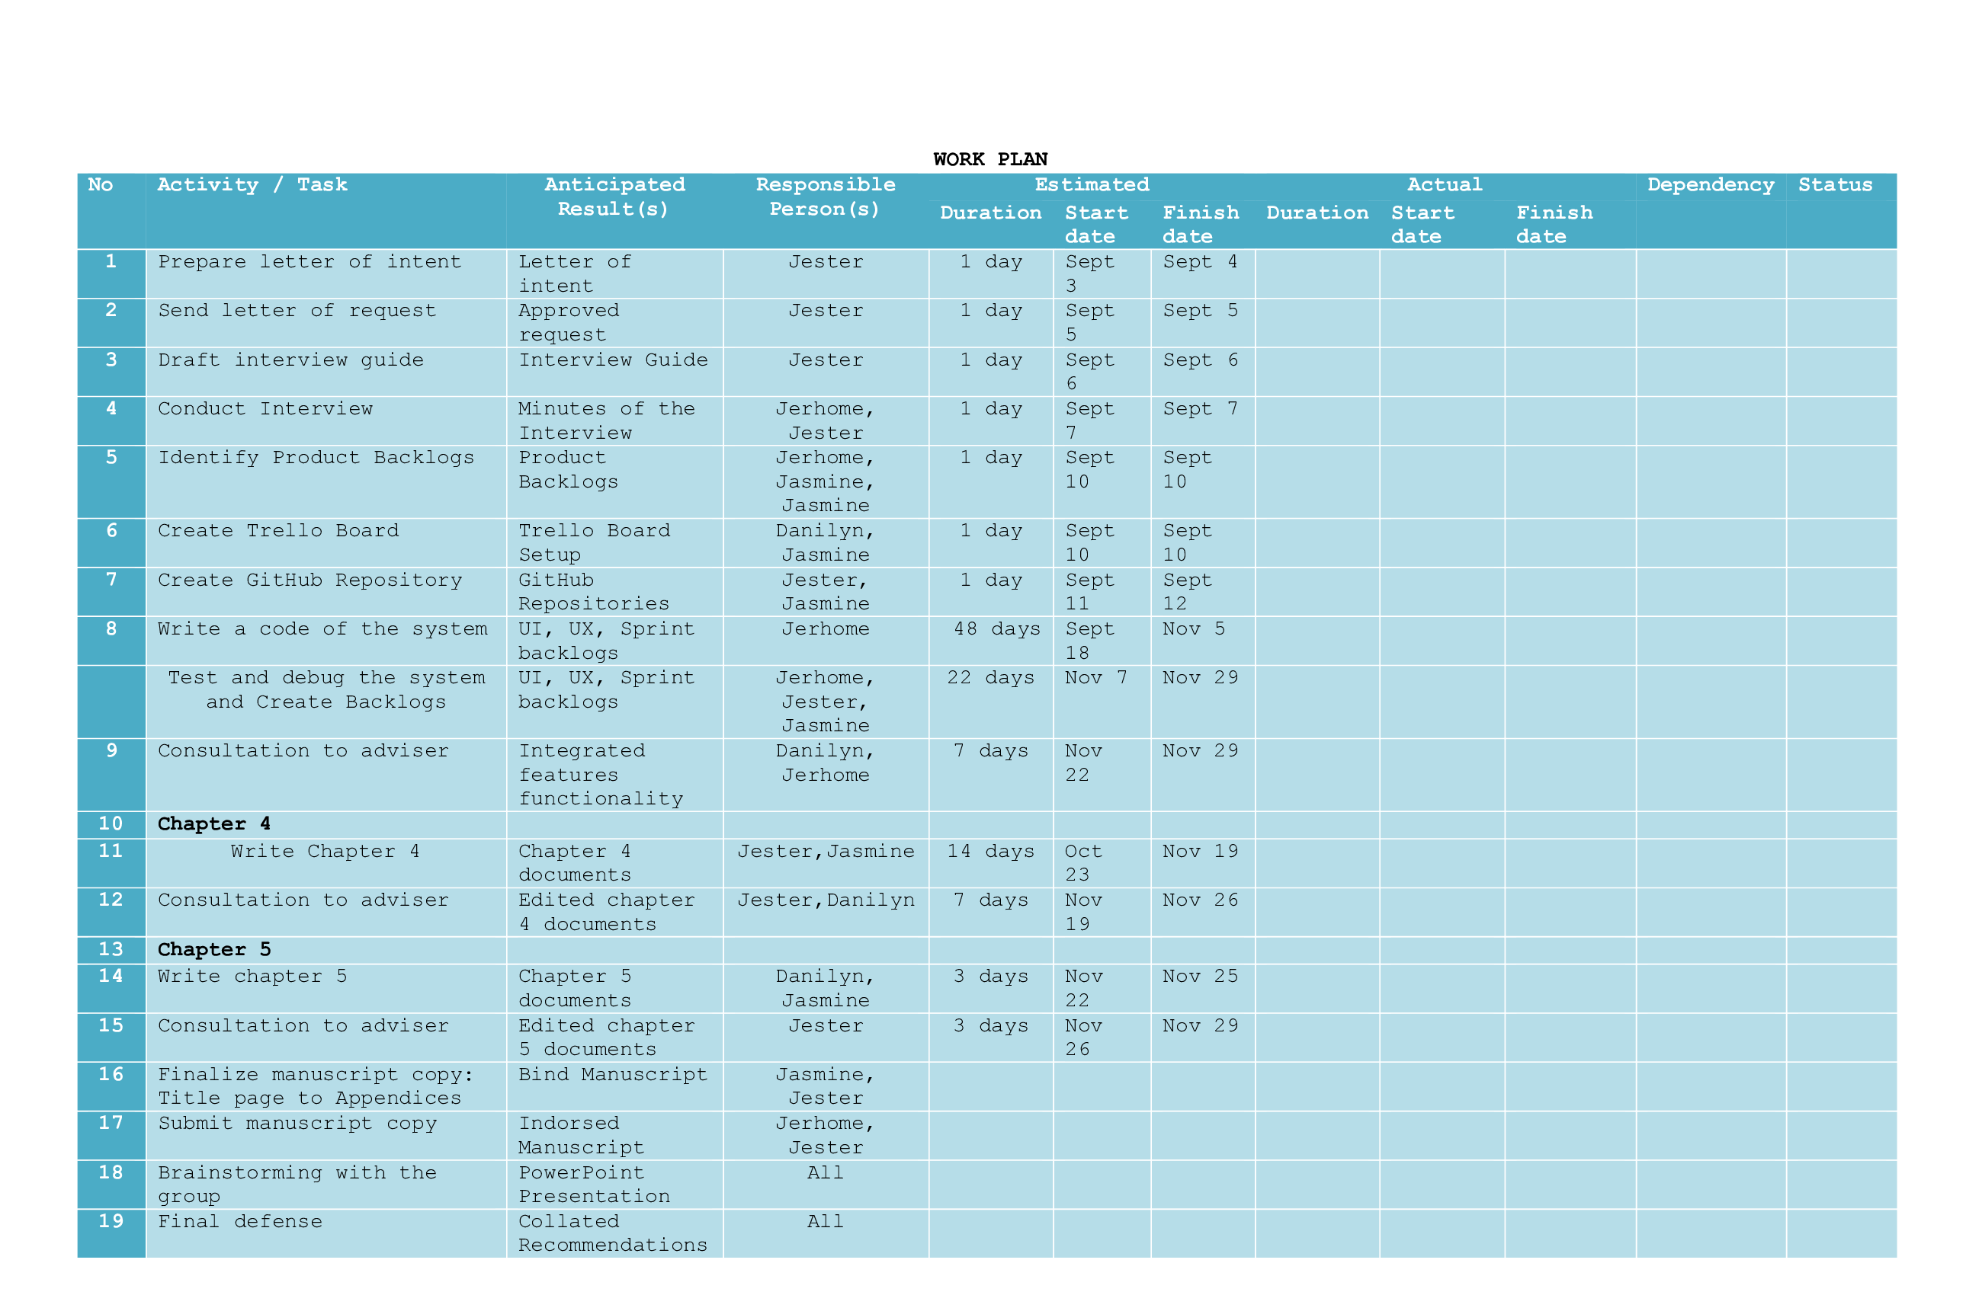

# Appendix C

# Letter to Conduct Studies

**REPUBLIC OF THE PHILIPPINES**

**PANGASINAN STATE UNIVERSITY**

Alaminos City Campus

**November 04 ,2022**

**MS. MARY C. DE GUZMAN**

*Municipal Tourism Officer*

*Bolinao, Pangasinan*

Madam:

Greetings Ms. De Guzman,

We are currently enrolled in the Bachelor of Science and Information Technology at Pangasinan State University – Alaminos City Campus and we are in the process of conducting a study on “TOURIST MONITORING SYSTEM FOR BOLINAO” in partial fulfillment of our requirements for Capstone Project 2.

We are humbly requesting your permission to conduct interviews, and observations, on the relevant processes of the Tourism Office that will help us to establish the scope and context of the project. We will treat every information shared and gathered with utmost confidentiality of our study will be highly appreciated response.

Thank you and looking forward to your positive response.

Sincerely,

**JERHOME T. REANTASO DANILYN V. BANOGON**

*Project Lead* *Member*

**JESTER EINSTEIN C. IBASAN JASMINE B. ZINAMPAN**

*Member Member*

Noted:

__________________ __

**CHRISTIAN PAUL O. CRUZ**

*Project Study Adviser*

__________________ __

**RUISSAN A. RAMOS, MIT**

*Department Chairperson*

*Information Technology*

Appendix D

# Interview Guide

The proponents in the study entitled, Tourist Management System for Bolinao had prepared the following sets of interview questions.

1. What is the peak season for tourist activities in Bolinao? How about the average number of tourists daily/weekly/monthly/annually?
2. What are the registered establishments and spots related to tourism in Bolinao? Is there any list of these available? Kindly share the offers of this establishments.
3. What is the primary workflow of Bolinao Tourism?
4. Who is responsible for processing tourist data?
5. How does information be handled in the office regarding tourist activities?
6. What is the information that are being processed? How does it help?
7. What does this collected tourist data mean to the office?
8. What is the existing process of Bolinao Tourism regarding monitoring tourists’ activities?
9. What is the current problem in the current process that is being ignored?
10. Do you feel like adding more interaction on the website like monitoring system? If yes, kindly enumerate.

Appendix E

# Use Case Diagram

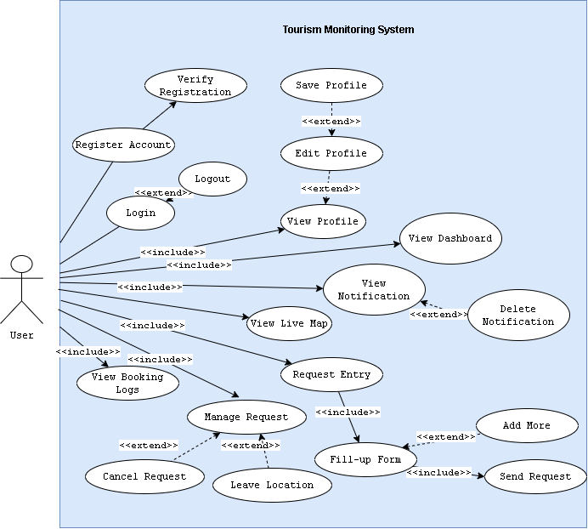

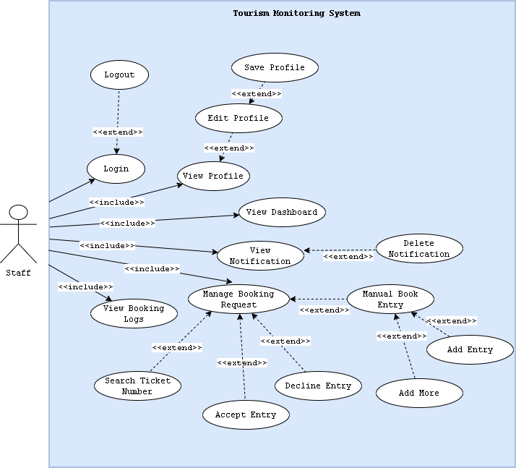

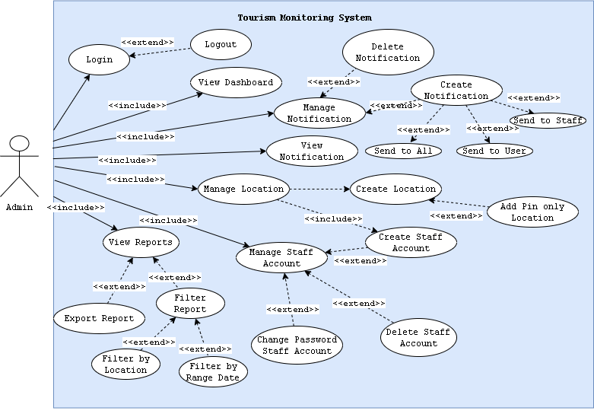

Appendix F

# Use Case Description

|  |  |  |
| --- | --- | --- |
| Use Case | Register | |
| Description | This is used to illustrate Signup in the system | |
| Actor | | System |
| Normal Flow | | |
| 2. Encode first name, last name, email, number, and password.  3. click Signup button.  5. Enter OTP Code from email inbox. | | 1. Display Sign up Page.  4. Send OTP via email.  6. Display Login page. |
| Except Flow (Encounter error in email or mismatch password) | | |
| 3. click Signup button.  5. Enter the valid email or password.  6. click Signup button  8. Enter OTP Code from email inbox. | | 4. Display error message for the email or password.  7. Send OTP via email.  8. Display Login Page. |

|  |  |  |
| --- | --- | --- |
| Use Case | Login | |
| Description | This is used to illustrate Login in the system | |
| Actor | | System |
| Normal Flow | | |
| 2. Encode email and password.  3. click Login button. | | 1. Display Login Page.  4. Display Dashboard. |
| Except Flow (Encounter error in password or phone number) | | |
| 3. click Login button.  5. Enter the correct password or email.  6. click Login button. | | 4. Display error message for the password or email.  7. Display Dashboard. |

|  |  |  |
| --- | --- | --- |
| Use Case | My Profile | |
| Description | This is used to illustrate My Profile in the system | |
| Actor | | System |
| Normal Flow | | |
| 2. Edit first name, or last name, or gender, or phone number, or email, or address.  3. click Save Profile button. | | 1. Display Profile Page.  4. Display Updated Successfully. |
| Except Flow (Encounter error editing profile) | | |
| 2. Edit empty first name, or last name, or gender, or phone number, or email, or address.  5. Edit correct first name, or last name, or gender, or phone number, or email, or address.  6. click Save Profile button. | | 3. Display error message for empty first name, or last name, or gender, or phone number, or email, or address  7. Display Updated Successfully. |

|  |  |  |
| --- | --- | --- |
| Use Case | Notification | |
| Description | This is used to illustrate Notification in the system | |
| Actor | | System |
| Normal Flow | | |
| 1. Click notification bell icon.  3. Click new notification. | | 2. Display new notification.  4. Display notification modal. |
| Alternate Flow | | |
| 3. Click View All.  5. Click View on chosen notification. | | 4. Redirect to Notifications Page.  6. Display notification modal.  7. Display Updated Successfully |

|  |  |  |
| --- | --- | --- |
| Use Case | Live Map | |
| Description | This is used to illustrate Live Map in the system | |
| Actor | | System |
| Normal Flow | | |
| 2. Click Location Pin. | | 1. Display Live Map Page.  3. Display live count balloon. |

|  |  |  |  |  |
| --- | --- | --- | --- | --- |
| Use Case | Request Entry | | | |
| Description | This is used to illustrate Request Entry in the system | | | |
| Actor | | System | | |
| Normal Flow | | | | |
| 2. Click Next.  4. Choose desired location.  5. Click Request. | | 1. Display Booking – User Info Page.  3. Display Booking – User Info – Additional Information Page  6. Display generated ticket number. | | |
| Except Flow (Encounter error in requesting entry) | | | | |
| 2. Click Next.  5. Edit Profile.  6. Go to Request Entry Page.  8. Click Next.  10. Choose desired location.  11. Click Request. | | 3. Display error message for empty address.  7. Display Booking – User Info Page.  9. Display Booking – User Info – Additional Information Page  12. Display generated ticket number. | | |
| Alternate Flow | | | | |
| 4. Choose desired location.  5. Click Add More.  6. Encode required fields  8. Click Request. | | | | 7. Show new fields.  9. Display generated ticket number. |

|  |  |  |
| --- | --- | --- |
| Use Case | Accept Entry | |
| Description | This is used to illustrate Accept Entry in the system | |
| Actor | | System |
| Normal Flow | | |
| 2. Verify Ticket Number from User.  3. Confirm Entry. | | 1. Display Pending Request.  4. Update logs. |
| Alternate Flow | | |
| 2. Click Add Button.  4. Encode required fields. | | 1. Display Pending Request.  3. Redirect to Manual Entry Page.  5. Update logs. |

|  |  |  |  |  |
| --- | --- | --- | --- | --- |
| Use Case | Add Location | | | |
| Description | This is used to illustrate Add Location in the system | | | |
| Actor | | System | | |
| Normal Flow | | | | |
| 2. Click Next.  4. Choose desired location.  5. Click Request. | | 1. Display Booking – User Info Page.  3. Display Booking – User Info – Additional Information Page  6. Display generated ticket number. | | |
| Except Flow (Encounter error in requesting entry) | | | | |
| 2. Click Next.  5. Edit Profile.  6. Go to Request Entry Page.  8. Click Next.  10. Choose desired location.  11. Click Request. | | 3. Display error message for empty address.  7. Display Booking – User Info Page.  9. Display Booking – User Info – Additional Information Page  12. Display generated ticket number. | | |
| Alternate Flow | | | | |
| 4. Choose desired location.  5. Click Add More.  6. Encode required fields  8. Click Request. | | | | 7. Show new fields.  9. Display generated ticket number. |

|  |  |  |
| --- | --- | --- |
| Use Case | Create Staff Account | |
| Description | This is used to illustrate Create Staff Account in the system | |
| Actor | | System |
| Normal Flow | | |
| 1. Click Create Account.  3. Choose Location.  4. Encode password.  5. Click Create Account inside Modal. | | 2. Show Create Account Modal.  6. Show Successful message in modal. |
| Except Flow (Encounter error in Creating Staff Account) | | |
| 1. Click Create Account.  3. Click Create Account inside Modal.  5. Choose Location.  6. Encode password.  7. Click Create Account inside Modal. | | 2. Show Create Account Modal.  4. Display error (No fields)  8. Show Successful message in modal. |

|  |  |  |
| --- | --- | --- |
| Use Case | Export Report | |
| Description | This is used to illustrate Generate Report in the system | |
| Actor | | System |
| Normal Flow | | |
| 1. Click Export as excel. | | 2. Download excel file. |
| Alternate Flow | | |
| 1. Choose Destination or All.  2. Choose Start Date and End Date.  3. Click Export as Excel. | | 4. Download excel file. |

Appendix G

# A picture containing text Description automatically generatedEntity Relationship Diagram

Appendix H

# Data Dictionary

|  |  |  |
| --- | --- | --- |
| **tr_db::admin_notifications** | | |
| Field Name | Type | Description |
| id (Primary) | bigint (20) | ID for query |
| sender | varchar (255) | Sender name |
| type | varchar (255) | Notification type |
| message | varchar (255) | Content of Message |
| status | varchar (255) | Status of Notification |
| sendto | varchar (255) | Where to send (user, admin, staff) |
| time | varchar (255) | Time of creation of notification |
| date | varchar (225) | Date of creation of notification |

|  |  |  |
| --- | --- | --- |
| **tr_db::approves** | | |
| Field Name | Type | Description |
| id (Primary) | bigint (20) | ID for query |
| booker_id | varchar (255) | Book ID |
| user_id | varchar (255) | User ID of User Accounts |
| staff_id | varchar (255) | User ID of Staff Accounts |
| first_name | varchar (255) | First name of the account |
| last_name | varchar (255) | Last name of the account |
| destination | varchar (255) | Destination of the account |
| gender | varchar (255) | Gender of the account |
| phone | varchar (255) | Phone number of the account |
| email | varchar (255) | Email address of the account |
| address | varchar (255) | Address of the account |
| book_number | varchar (255) | Generated Ticket Number |
| groups | varchar (255) | Number of Groups |

|  |  |  |
| --- | --- | --- |
| **tr_db::book_data** | | |
| Field Name | Type | Description |
| id (Primary) | bigint (20) | ID for query |
| booker_id | varchar (255) | Book ID |
| first_name | varchar (255) | User ID of User Accounts |
| last_name | varchar (255) | User ID of Staff Accounts |
| destination | varchar (255) | Destination of Account |
| gender | varchar (255) | Gender of the account |
| phone | varchar (255) | Phone number of the account |
| address | varchar (255) | Address of the account |
| book_number | varchar (255) | Generated Ticket Number |
| time_date | varchar (255) | Time & Date of Approval |
| day | varchar (255) | Day (Mon, Tues, etc.) |

|  |  |  |
| --- | --- | --- |
| **tr_db::book_requests** | | |
| Field Name | Type | Description |
| id (Primary) | bigint (20) | ID for query |
| user_id | varchar (255) | User ID of User Accounts |
| first_name | varchar (255) | First name of the account |
| last_name | varchar (255) | Last name of the account |
| destination | varchar (255) | Destination of the account |
| gender | varchar (255) | Gender of the account |
| phone | varchar (255) | Phone number of the account |
| email | varchar (255) | Email address of the account |
| address | varchar (255) | Address of the account |
| groups | varchar (255) | Number of Groups (0 or >1) |
| book_number | varchar (255) | Generated Ticket Number |
| status | tinytext | Status of Request |
| time_date | varchar (255) | Time & Date of Request |

|  |  |  |
| --- | --- | --- |
| **tr_db::daily reset** | | |
| Field Name | Type | Description |
| id (Primary) | bigint (20) | ID for query |
| user_id | varchar (255) | User ID of User Accounts |
| today | varchar (255) | Daily Reset Time Today |
| tomorrow | varchar (255) | Daily Reset Time Tomorrow |

|  |  |  |
| --- | --- | --- |
| **tr_db::group_approves** | | |
| Field Name | Type | Description |
| id (Primary) | bigint (20) | ID for query |
| booker_id | varchar (255) | Book ID |
| first_name | varchar (255) | First name of the account |
| last_name | varchar (255) | Last name of the account |
| destination | varchar (255) | Destination of the account |
| gender | varchar (255) | Gender of the account |
| phone | varchar (255) | Phone number of the account |
| address | varchar (255) | Address of the account |
| book_number | varchar (255) | Generated Ticket Number |
| time date | varchar (255) | Time & Date of Creation |
| ap_date | date | Date of Approval |

|  |  |  |
| --- | --- | --- |
| **tr_db::map_locations** | | |
| Field Name | Type | Description |
| id (Primary) | bigint (20) | ID for query |
| latitude | varchar (255) | Latitude of Map |
| longitude | varchar (255) | Longitude of Map |
| name | varchar (255) | Location Name |
| visit_count | varchar (255) | Visit Count of Location |
| total_visit | tinytext | Total Visit Increment |
| link | tinytext | Location Link |
| type | tinyint (4) | Pin or Establishment/Site |
| date | varchar (255) | Date of Creation |

|  |  |  |
| --- | --- | --- |
| **tr_db::staff_alerts** | | |
| Field Name | Type | Description |
| id (Primary) | Bigint (20) | ID for query |
| sender | varchar (255) | Sender name |
| type | varchar (255) | Notification type |
| message | varchar (255) | Content of Message |
| status | varchar (255) | Status of Notification |
| sendto | varchar (255) | Where to send(user, admin,staff) |
| time | varchar (255) | Time of creation of notification |
| date | varchar (225) | Date of creation of notification |

|  |  |  |
| --- | --- | --- |
| **tr_db::staff_notifications** | | |
| Field Name | Type | Description |
| id (Primary) | bigint (20) | ID for query |
| creator_id | varchar (255) | Creator ID |
| type | varchar (255) | Notification type |
| message | varchar (255) | Content of Message |
| status | varchar (255) | Status of Notification |
| time | varchar (255) | Time of creation of notification |
| date | varchar (225) | Date of creation of notification |

|  |  |  |
| --- | --- | --- |
| **tr_db::group_approves** | | |
| Field Name | Type | Description |
| id (Primary) | bigint (20) | ID for query |
| first_name | varchar (255) | Book ID |
| last_name | varchar (255) | First name of the account |
| phone | varchar (255) | Last name of the account |
| otp | varchar (255) | Generated OTP Code |
| email | varchar (255) | Email address of the account |
| gender | varchar (255) | Gender of the account |
| address | varchar (255) | Address of the account |
| img_name | varchar (255) | Profile image file name |
| img_size | varchar (255) | Image image file size |
| verification_code | varchar (255) | Generated verification code |
| is_verified | int (11) | Int-Boolean value for verification |
| password | varchar (255) | Hashed password |
| role | varchar (255) | User Level by number |
| book_number | varchar (255) | Generated Ticket Number |
| location | varchar (255) | Current Destination |
| remember_token | varchar (100) | Remember value |

|  |  |  |
| --- | --- | --- |
| **tr_db::user_notifications** | | |
| Field Name | Type | Description |
| id (Primary) | bigint (20) | ID for query |
| creator_id | varchar (255) | Creator ID |
| type | varchar (255) | Notification type |
| message | varchar (255) | Content of Message |
| status | varchar (255) | Status of Notification |
| time | varchar (255) | Time of creation of notification |
| date | varchar (225) | Date of creation of notification |

Appendix I

# Acceptability Questionnaire

ACCEPTABILITY TOURISM MONITORING SYSTEM FOR BOLINAO

(Adapted from ISO 9126-1 by McCall (1997))

Date: _____________________

Name of Respondent (optional): __________________________________

Sex: __ Male __ Female

Direction: Please evaluate/rate the following items to determine the acceptability of the Tourism Monitoring System for Bolinao by checking the corresponding box using the scale below:

4 – Acceptable

3 – Moderately Acceptable

2 – Fairly Unacceptable

1 – Poorly Unacceptable

|  |  |  |  |  |  |
| --- | --- | --- | --- | --- | --- |
| **Functionality** | | 4 | 3 | 2 | 1 |
| 1 | Suitability – The functions of the system are appropriate. |  |  |  |  |
| 2 | Accuracy – The system’s results are accurate. |  |  |  |  |
| 3 | Compliance – It adheres to existing standards and policies. |  |  |  |  |
| 4 | Security – It prevents unauthorized access. |  |  |  |  |
| **Reliability** | |  |  |  |  |
| 1 | Maturity – There is minimal frequency of software faults/failures. |  |  |  |  |
| 2 | Fault Tolerance – The system has capability of handling system errors. |  |  |  |  |
| 3 | Recoverability – System’s performance is re-establishing from failure. |  |  |  |  |
| **Usability** | |  |  |  |  |
| 1 | Understandability – Concepts are easily recognized. |  |  |  |  |
| 2 | Learnability – Effort in learning the system is reduced. |  |  |  |  |
| 3 | Operability – The system is easy to use or operate. |  |  |  |  |
| **Efficiency** | |  |  |  |  |
| 1 | Time Behavior – There is fast response time of the system. |  |  |  |  |
| 2 | Resource Behavior – Resources used for system performance are accessible. |  |  |  |  |
| **Maintainability** | |  |  |  |  |
| 1 | Analyzability – There is less effort in identifying system failure causes. |  |  |  |  |
| 2 | Changeability – Effort in modifying the system |  |  |  |  |
| 3 | Stability – Sensitivity to modification |  |  |  |  |
| **Portability** | |  |  |  |  |
| 1 | Adaptability – Specification changes are done easily. |  |  |  |  |
| 2 | Installability – There is effortless process of installing the system. |  |  |  |  |
| 3 | Conformance – System is compliant to portability standards. |  |  |  |  |

Comments:

_______________________________________________________________________________________________________________________________________________________________________________________________________________________________________________________________

This is the end of the survey questionnaire. Thank you very much for your time and generous cooperation.

_______________________

Respondent’s Signature

Appendix J

# Tabulation of Results

**All Respondents**

|  |  |  |  |
| --- | --- | --- | --- |
|  | | **Mean** | **Description** |
| **Functionality** | | 3.8 | Acceptable |
| 1 | Suitability – The functions of the system are appropriate. | 3.90 | Acceptable |
| 2 | Accuracy – The system’s results are accurate. | 3.78 | Acceptable |
| 3 | Compliance – It adheres to existing standards and policies. | 3.74 | Acceptable |
| 4 | Security – It prevents unauthorized access. | 3.76 | Acceptable |
| **Reliability** | | 3.68 | Acceptable |
| 1 | Maturity – There is minimal frequency of software faults/failures. | 3.56 | Acceptable |
| 2 | Fault Tolerance – The system has capability of handling system errors. | 3.72 | Acceptable |
| 3 | Recoverability – System’s performance is re-establishing from failure. | 3.76 | Acceptable |
| **Usability** | | 3.82 | Acceptable |
| 1 | Understandability – Concepts are easily recognized. | 3.87 | Acceptable |
| 2 | Learnability – Effort in learning the system is reduced. | 3.76 | Acceptable |
| 3 | Operability – The system is easy to use or operate. | 3.83 | Acceptable |
| **Efficiency** | | 3.83 | Acceptable |
| 1 | Time Behavior – There is fast response time of the system. | 3.85 | Acceptable |
| 2 | Resource Behavior – Resources used for system performance are accessible. | 3.81 | Acceptable |
| **Maintainability** | | 3.73 | Acceptable |
| 1 | Analyzability – There is less effort in identifying system failure causes. | 3.78 | Acceptable |
| 2 | Changeability – Effort in modifying the system | 3.74 | Acceptable |
| 3 | Stability – Sensitivity to modification | 3.67 | Acceptable |
| **Portability** | | 3.82 | Acceptable |
| 1 | Adaptability – Specification changes are done easily. | 3.74 | Acceptable |
| 2 | Installability – There is effortless process of installing the system. | 3.87 | Acceptable |
| 3 | Conformance – System is compliant to portability standards. | 3.85 | Acceptable |

Appendix K

**List of Registered Establishments**

|  |  |  |  |
| --- | --- | --- | --- |
| Offers | Name of Establishment | [Gmail](mailto:ahhillside@gmail.com) | Location |
| Resort | A&H Hillside Resort | [ahhillside@gmail.com](mailto:ahhillside@gmail.com) | <https://goo.gl/maps/yMdjEmYSQaD2pvCK7> |
| Resort | Betty's Whitesand Beach | [bettyswhitesand10@gmail.com](mailto:bettyswhitesand10@gmail.com) | <https://goo.gl/maps/vrX9nNrMd6noMUiBA> |
| Resort | Birdland Beach Club Inc | [emruthpadilla@yahoo.com](mailto:emruthpadilla@yahoo.com) | <https://g.page/birdlandbeachclub?share> |
| Mabuhay Accomodation | Buccat Transienthouse | [williebuccat47@gmail.com](mailto:williebuccat47@gmail.com) | <https://goo.gl/maps/zv9HqhqTEf9G4E9PA> |
| Mabuhay Accomodation | Abode21 Guest House | [abode21house@gmail.com](mailto:abode21house@gmail.com) | <https://goo.gl/maps/dQi1zifBUGH39upM7> |
| Mabuhay Accomodation | Alona's Traditional Filipino Resthouse | [alonaovk7275@gmail.com](mailto:alonaovk7275@gmail.com) | <https://goo.gl/maps/y1zUNWaLWYsVQE3T8> |
| Resort | Ams Beach Resort | [alonaovk7275@gmail.com](mailto:alonaovk7275@gmail.com) | <https://goo.gl/maps/y1zUNWaLWYsVQE3T8> |
| Restaurant | B2l Sizzling House | [Lozanoemaemz@gmail.com](mailto:Lozanoemaemz@gmail.com) |  |
| Restaurant | Badak Restobar | [ritacatabay02@yahoo.com](mailto:ritacatabay02@yahoo.com) | <https://goo.gl/maps/GfhFexLFmUL3HEzn7> |
| Mabuhay Accomodation | Bolinao Beach House | [dahliaecal02@yahoo.com](mailto:dahliaecal02@yahoo.com) |  |
| Restaurant | Bolinao Seafood Grill Atbp. | [pangananbolinaoseafood@gmail.com](mailto:pangananbolinaoseafood@gmail.com) | <https://goo.gl/maps/ahsqWYWtVBse6n829> |
| Resort | Carino's Beach Resort | [perlitocarino@yahoo.com](mailto:perlitocarino@yahoo.com) | <https://goo.gl/maps/ScUUv4nKJFcmxhJ3A> |
| Restaurant | Casa Almarenzo Bed And Breakfast Resort | [reservations@casaalmarenzo.com](mailto:reservations@casaalmarenzo.com) | <https://goo.gl/maps/os3sekYZpsnNZ8u48> |
| Resort | Casa Carmencita Beach Resort | [reyvaldez0610@gmail.com](mailto:reyvaldez0610@gmail.com) | <https://goo.gl/maps/cYJCNiNVY3SfHirp7> |
| Resort | Casa Carolina Beach Resort | [charmilyn.abad.wat2016@gmail.com](mailto:charmilyn.abad.wat2016@gmail.com) | <https://goo.gl/maps/gDVG1CszzbAX3y5N8> |
| Mabuhay Accomodation | Casa Cristobal Inn | [imeldaschoenle01@yahoo.com](mailto:imeldaschoenle01@yahoo.com) | <https://goo.gl/maps/w59JraKNPXrRFKDx6> |
| Resort | Cindy's Bay View Resort | [cindysbayview@gmail.com](mailto:cindysbayview@gmail.com) |  |
| Tourism Recreation Center | Cindy's Cave Eco Park | [cindyscave@gmail.com](mailto:cindyscave@gmail.com) | <https://goo.gl/maps/4QyYNPJy96MYEAu38> |
| Resort | Cocos Beach Resort | [sidcocosbeach@gmail.com](mailto:sidcocosbeach@gmail.com) | <https://goo.gl/maps/FTyMSBMxxcAiQn3A8> |
| Resort | Cool Spot Beach Resort | [tiglaocharizza@gmail.com](mailto:tiglaocharizza@gmail.com) | <https://goo.gl/maps/JezWtRF6u4qdVP7j9> |
| Mabuhay Accomodation | Corpuz Transient House | [belindacorpuz01@yahoo.com](mailto:belindacorpuz01@yahoo.com) |  |
| Resort | Costa Del Fuego Beach Resort | [costadelfuegobeachresort@gmail.com](mailto:costadelfuegobeachresort@gmail.com) | <https://goo.gl/maps/KVL2Vm1VgmfEzmbH7> |
| Mabuhay Accomodation | D'haven Shores Inn | [havenshoresinn@gmail.com](mailto:havenshoresinn@gmail.com) | <https://goo.gl/maps/E5AVf4qcMGzA2Qci6> |
| Mabuhay Accomodation | De Vera's Transient Inn | [bettydevera@yahoo.com](mailto:bettydevera@yahoo.com) | <https://goo.gl/maps/4Fmdu3djpsGjDsyh9> |
| Mabuhay Accomodation | Del Luna Transient House | [bened8ct12@gmail.com](mailto:bened8ct12@gmail.com) | <https://goo.gl/maps/MDCedvFj5TYeqvy38> |
| Mabuhay Accomodation | Dela Cruz Transient House | [gemmapanes24@gmail.com](mailto:gemmapanes24@gmail.com) | <https://goo.gl/maps/ZGm9jtevTWZHPYYP9> |
| Resort | Diobes Beach Resort | [diobesorlanda@yahoo.com](mailto:diobesorlanda@yahoo.com) | <https://goo.gl/maps/ZdYGizBg5upLyDfW8> |
| Mabuhay Accomodation | Dor's Room Rental | [dorsroomrental@yahoo.com](mailto:dorsroomrental@yahoo.com) |  |
| Mabuhay Accomodation | Duclosan Convenient Mini Resto And Aiko Beach | [joanquebada01@yahoo.com](mailto:joanquebada01@yahoo.com) | <https://goo.gl/maps/ddegyg4jjUwysjUT9> |
| Resort | El Pescador Resort Hotel | [elpescadorofficial@gmail.com](mailto:elpescadorofficial@gmail.com) | <https://g.page/Elpescadorbolinao?share> |
| Mabuhay Accomodation | Elling's White Sand Transient Inn | [ildefonsocaslibjr@yahoo.com](mailto:ildefonsocaslibjr@yahoo.com) | <https://goo.gl/maps/V5Ht9TtanvXLL7P48> |
| Mabuhay Accomodation | Final Destination Villa Rental | [floridaweise@yahoo.com](mailto:floridaweise@yahoo.com) | <https://goo.gl/maps/ZMDF8cLxpaFLBJHU9> |
| Resort | Gerlita Beach Resort | [gerlitabeachresort@gmail.com](mailto:gerlitabeachresort@gmail.com) | <https://goo.gl/maps/YAiLzR7LZRjiPUoY6> |
| Mabuhay Accomodation | Glab Lavirginia Beach House | [gemmacramirez56@yahoo.com](mailto:gemmacramirez56@yahoo.com) | <https://goo.gl/maps/fYpZKgmkMZw3hDHA7> |
| Mabuhay Accomodation | Gran Canaria Vacation Place & Resto Bar | [grancanariapatar1@gmail.com](mailto:grancanariapatar1@gmail.com) | <https://goo.gl/maps/7JPx9WBdVSKCTJRD8> |
| Resort | Holy Land Beach Resort | [frudelinz@yahoo.com](mailto:frudelinz@yahoo.com) | <https://goo.gl/maps/BNJP5SGJyuDhEoAR7> |
| Resort | Honrada's Beach Resort | [nathanielangelito@yahoo.com](mailto:nathanielangelito@yahoo.com) | <https://goo.gl/maps/kecA6Hr65SZSFV6r9> |
| Resort | Hotel G Beach Resort And Restobar | [gbeachresort@gmail.com](mailto:gbeachresort@gmail.com) | <https://goo.gl/maps/TD1ZZXHjLvQAbFkF9> |
| Mabuhay Accomodation | Inson's Place Room Rental | [joanhonrada@yahoo.com](mailto:joanhonrada@yahoo.com) | <https://goo.gl/maps/DqxXL9BzuRLUbQFq9> |
| Restaurant | Jiajeimseu Korean Foodmart | [jamesghia12262015@gmail.com](mailto:jamesghia12262015@gmail.com) | <https://goo.gl/maps/t1e27Tf5pEZJ8GUg8> |
| Mabuhay Accomodation | Jjam's Transient Room Rental | [jjamstransient21@gmail.com](mailto:jjamstransient21@gmail.com) | <https://goo.gl/maps/TBpqMw5kFFqFhMPd9> |
| Restaurant | Kainan Sa Arko | [angelierosecanayon@gmail.com](mailto:angelierosecanayon@gmail.com) | <https://goo.gl/maps/Z2YfdCC5xt3tpvuq8> |
| Mabuhay Accomodation | Knb West Villa Inn | [knbwestvillainn21@gmail.com](mailto:knbwestvillainn21@gmail.com) | <https://goo.gl/maps/jXaxXQaQq1cnDcFR9> |
| Resort | Kokopeli Beach Resort | [liceralderenerose@gmail.com](mailto:liceralderenerose@gmail.com) | <https://goo.gl/maps/DY2os87sYk2kkwXM7> |
| Mabuhay Accomodation | Kubhotel Co. | [kubhotels@gmail.com](mailto:kubhotels@gmail.com) | <https://goo.gl/maps/VeJVB6vYdwdPQtFc6> |
| Mabuhay Accomodation | Kuya Ambot Staycation Beach House | [franciscojoel0463@gmail.com](mailto:franciscojoel0463@gmail.com) | <https://goo.gl/maps/e8CZBaitaMZZ2Zcm6> |
| Mabuhay Accomodation | Kuya Benjie's Transient Rooms | [benjaminsarte@yahoo.com](mailto:benjaminsarte@yahoo.com) | <https://goo.gl/maps/Dy7kcccU1LrrPj7n6> |
| Resort | Kyla's Resort | [venalynfallorina24@gmail.com](mailto:venalynfallorina24@gmail.com) | <https://goo.gl/maps/BPfTFCNf2hD9fbLSA> |
| Mabuhay Accomodation | La Casa De Quinn | [lacasadequinnpool@gmail.com](mailto:lacasadequinnpool@gmail.com) | <https://goo.gl/maps/YwftpxmspnErNQu56> |
| Resort | Liberty Beach Resort | [libertybeachresort2011@gmail.com](mailto:libertybeachresort2011@gmail.com) | <https://goo.gl/maps/VFa1Lb4FFPYD783a8> |
| Mabuhay Accomodation | Liway Beach Huts | [cartherineabalos68@gmail.com](mailto:cartherineabalos68@gmail.com) | <https://goo.gl/maps/xtbTjyqDN1vXBkxQA> |
| Mabuhay Accomodation | Los Ecijano's Inn | [losecijanosinn1@gmail.com](mailto:losecijanosinn1@gmail.com) | <https://goo.gl/maps/eToLeTYxp8KZw2xEA> |
| Mabuhay Accomodation | Magdha's Transient House | [magdhastransient04@gmail.com](mailto:magdhastransient04@gmail.com) | <https://goo.gl/maps/9HK5H8UKJ4nB64RZ8> |
| Mabuhay Accomodation | Makoko Sa Baybay | [miguel.natividad@rocketmail.com](mailto:miguel.natividad@rocketmail.com) | <https://goo.gl/maps/itDtCCziBVxPVkHH6> |
| Mabuhay Accomodation | Mario's Homestay | [marioshomestay12@gmail.com](mailto:marioshomestay12@gmail.com) |  |
| Mabuhay Accomodation | Mejia's Beach House | [edwincmejia@yahoo.com](mailto:edwincmejia@yahoo.com) | <https://goo.gl/maps/3AH8uqJEBfidknnQ7> |
| Mabuhay Accomodation | Mel-Gin Beach Hut Rental | [ricmorganizta@yahoo.com](mailto:ricmorganizta@yahoo.com) | <https://goo.gl/maps/1KPP3qrgKRiBizXKA> |
| Resort | Mia Al Mar Resort | [alsanchez.mci@gmail.com](mailto:alsanchez.mci@gmail.com) | <https://g.page/MiaAlMarBolinao?share> |
| Mabuhay Accomodation | Michael's Homestay | [geraldtamondong@gmail.com](mailto:geraldtamondong@gmail.com) | <https://goo.gl/maps/iRAQ4fDZ4pcNHm3B9> |
| Resort | Mjo White Sand Dream Resort | [mjowhitesanddreamresort@gmail.com](mailto:mjowhitesanddreamresort@gmail.com) | <https://goo.gl/maps/9NGiS6yv6Z3UFcWk8> |
| Mabuhay Accomodation | Myl Transient Room | [apostolsherrydee@gmail.com](mailto:apostolsherrydee@gmail.com) | <https://goo.gl/maps/sPZPmea4LXGRmn9dA> |
| Resort | Nelly's White Sand Beach Resort | [nellyramirez58@yahoo.com](mailto:nellyramirez58@yahoo.com) | <https://goo.gl/maps/88bpJPg7zgBxGtzp8> |
| Mabuhay Accomodation | Noe's Room Rental | [noesarkbolinao@gmail.com](mailto:noesarkbolinao@gmail.com) |  |
| Mabuhay Accomodation | Patar Summer Inn | [patarsummerinn@gmail.com](mailto:patarsummerinn@gmail.com) | <https://goo.gl/maps/BqBfWQWbVc1BpsDx9> |
| Resort | Paz Beach Resort | [pazbeachresort@gmail.com](mailto:pazbeachresort@gmail.com) |  |
| Resort | Pearlcasa Resort | [pearlcasabr@gmail.com](mailto:pearlcasabr@gmail.com) | <https://goo.gl/maps/RMvLeVmwbBqdHbsf7> |
| Resort | Precious Zion Beach Resort | [fujiapplelua@gmail.com](mailto:fujiapplelua@gmail.com) | <https://goo.gl/maps/NXPndeKeFZCwNpa99> |
| Mabuhay Accomodation | Puerto Del Sol Beach Resort And Hotel Club | [sales1.puertodelsol@gmail.com](mailto:sales1.puertodelsol@gmail.com) | <https://goo.gl/maps/gbcJqDMuo729QLo67> |
| Mabuhay Accomodation | Punta Riviera Del Mar Inc. | [puntarivieraresort@yahoo.com](mailto:puntarivieraresort@yahoo.com) | <https://goo.gl/maps/AFTChvJDYLSfVrEi6> |
| Resort | R-M Beach Resort | [renecapena05@yahoo.com](mailto:renecapena05@yahoo.com) | <https://goo.gl/maps/G5YGFUBeuYBnfXzZA> |
| Mabuhay Accomodation | Racniel Beach House Rental | [racnielbeachhouserental@gmail.com](mailto:racnielbeachhouserental@gmail.com) | <https://goo.gl/maps/myXmcizZL85MhmCG8> |
| Resort | River Village Resort | [rivervillageresort2022@gmail.com](mailto:rivervillageresort2022@gmail.com) | <https://goo.gl/maps/RYF5q6Cmwd3D4Wob6> |
| Mabuhay Accomodation | Rock Formation View Beach | [rosalyncatabay@yahoo.com](mailto:rosalyncatabay@yahoo.com) | <https://goo.gl/maps/yAQbk7F7MWrb85ht9> |
| Resort | Scl Garden Resort | [sclgardenresort@yahoo.com](mailto:sclgardenresort@yahoo.com) | <https://goo.gl/maps/woZgh1qR273tEn6o7> |
| Mabuhay Accomodation | Sea-Esta Beach House | [randyohonrada@yahoo.com](mailto:randyohonrada@yahoo.com) | <https://goo.gl/maps/oSjsBB9u4bAKPewLA> |
| Mabuhay Accomodation | Serenity Inn | [aliciaebidag01@yahoo.com](mailto:aliciaebidag01@yahoo.com) | <https://goo.gl/maps/ESECqjwwUQw5UJUC8> |
| Resort | Shaded Sand Beach Resort | [jiebenj@yahoo.com](mailto:jiebenj@yahoo.com) | <https://goo.gl/maps/FdFzyZ4yEVTQsh7V9> |
| Resort | Stella's Place Beach Resort | [stellasplace10@gmail.com](mailto:stellasplace10@gmail.com) | <https://goo.gl/maps/tHCzYZVUWevx1RYbA> |
| Mabuhay Accomodation | Sundowners Vacation Villas | [laurie.labuson@sundowners.biz](mailto:laurie.labuson@sundowners.biz) | <https://goo.gl/maps/S2ZKDkdSHJmHo8HZ7> |
| Resort | Taberna De Orlanda Resort | [pauloorlanda@yahoo.com](mailto:pauloorlanda@yahoo.com) | <https://goo.gl/maps/mv8akELvHsWn4QUc8> |
| Resort | Treasures Of Bolinao Beach Resort | [info@treasuresofbolinao.com](mailto:info@treasuresofbolinao.com) | <https://g.page/treasuresofbolinao?share> |
| Restaurant | Tummy Teasers Foodhouse And Bakeshop | [jayrontorres@yahoo.com](mailto:jayrontorres@yahoo.com) | <https://goo.gl/maps/vTgwmcgZhLMphnR1A> |
| Mabuhay Accomodation | Veue Beach Cabins | [info@veue.ph](mailto:info@veue.ph) | <https://goo.gl/maps/JdveMjyEbG5qQbjF6> |
| Resort | Villa Estrella Beach Resort | [casaestrellapatar@gmail.com](mailto:casaestrellapatar@gmail.com) |  |
| Mabuhay Accomodation | Villa Laguisma Transient House | [villalaguismatransient@gmail.com](mailto:villalaguismatransient@gmail.com) |  |
| Resort | Villa Soledad Beach Resort, Corp. | [villasoledadbeachresort@yahoo.com](mailto:villasoledadbeachresort@yahoo.com) | <https://goo.gl/maps/cXuhHY2zUYcVSCuQ9> |
| Mabuhay Accomodation | Wrc Beach House | [wrcbeachresort@gmail.com](mailto:wrcbeachresort@gmail.com) |  |
| Restaurant | Yobistro By The Sea, Inc. Doing Business Under Ciao | [ciao.sundowners@gmail.com](mailto:ciao.sundowners@gmail.com) |  |

**Total Number of Registered Establishments**

|  |  |
| --- | --- |
| Offers | Number |
| Mabuhay Accommodation | 44 |
| Resort | 35 |
| Restaurant | 8 |
| Tourism Recreation Center | 1 |
| Total Number: | **88** |

Appendix L

**Documentation**

**Demonstration of the System**

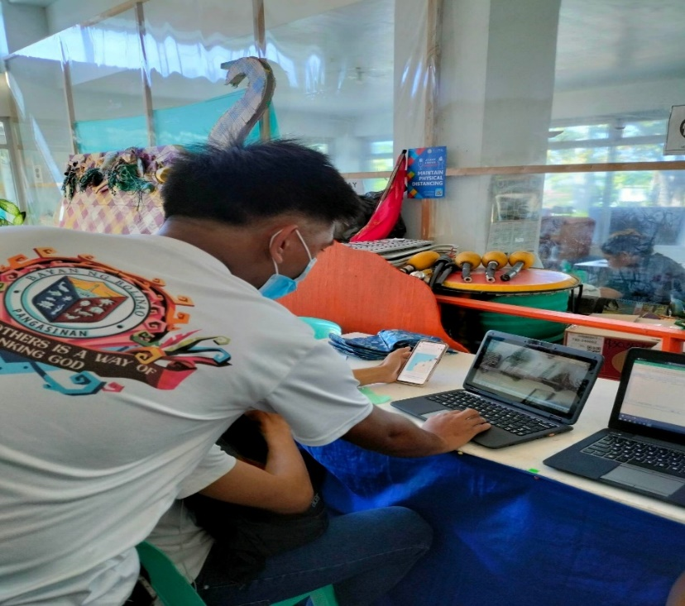

System Functionality testing by Mr. Boreas of Tourism Office of Bolinao.

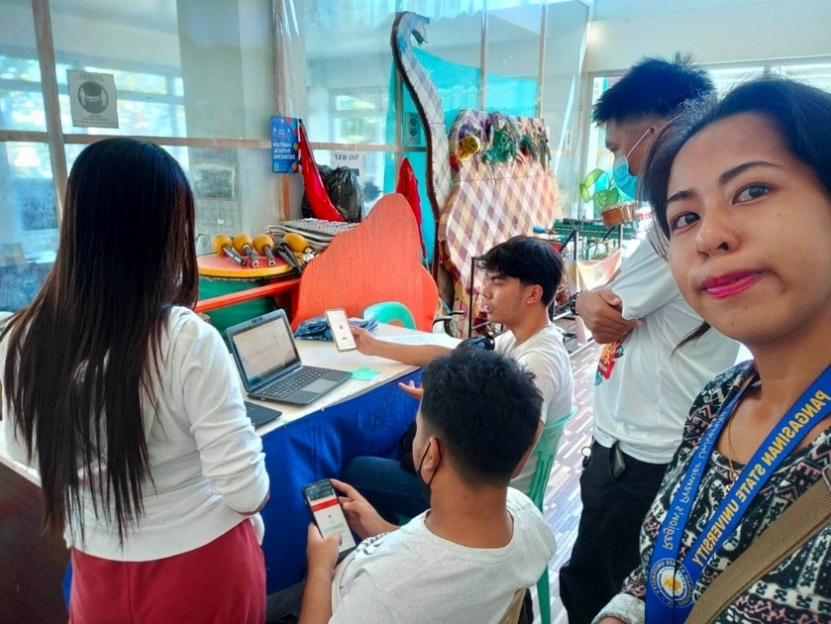

System demonstration of UI responsiveness in smartphones.

System demonstration of the different user level such as normal user, staff, and super admin.

System evaluation of Mr. Boreas after the demonstration.



Another system evaluation to an IT Expert and staff of Tourism Office of Bolinao.

**Acceptability Test in PSU ACC – IT Experts**

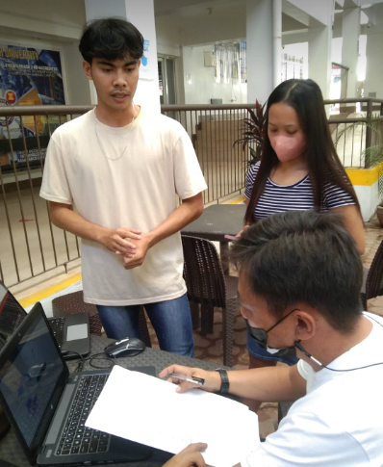

System evaluation of Mr. Raborar, an IT staff of PSU -ACC.

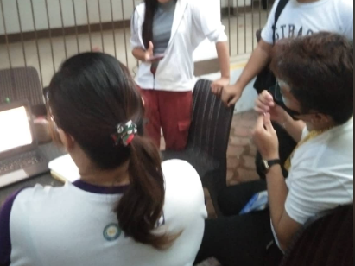

System demonstration other IT experts of PSU – ACC this includes security checking and UI evaluations.

**Manual Registration Form of Tourism Office**

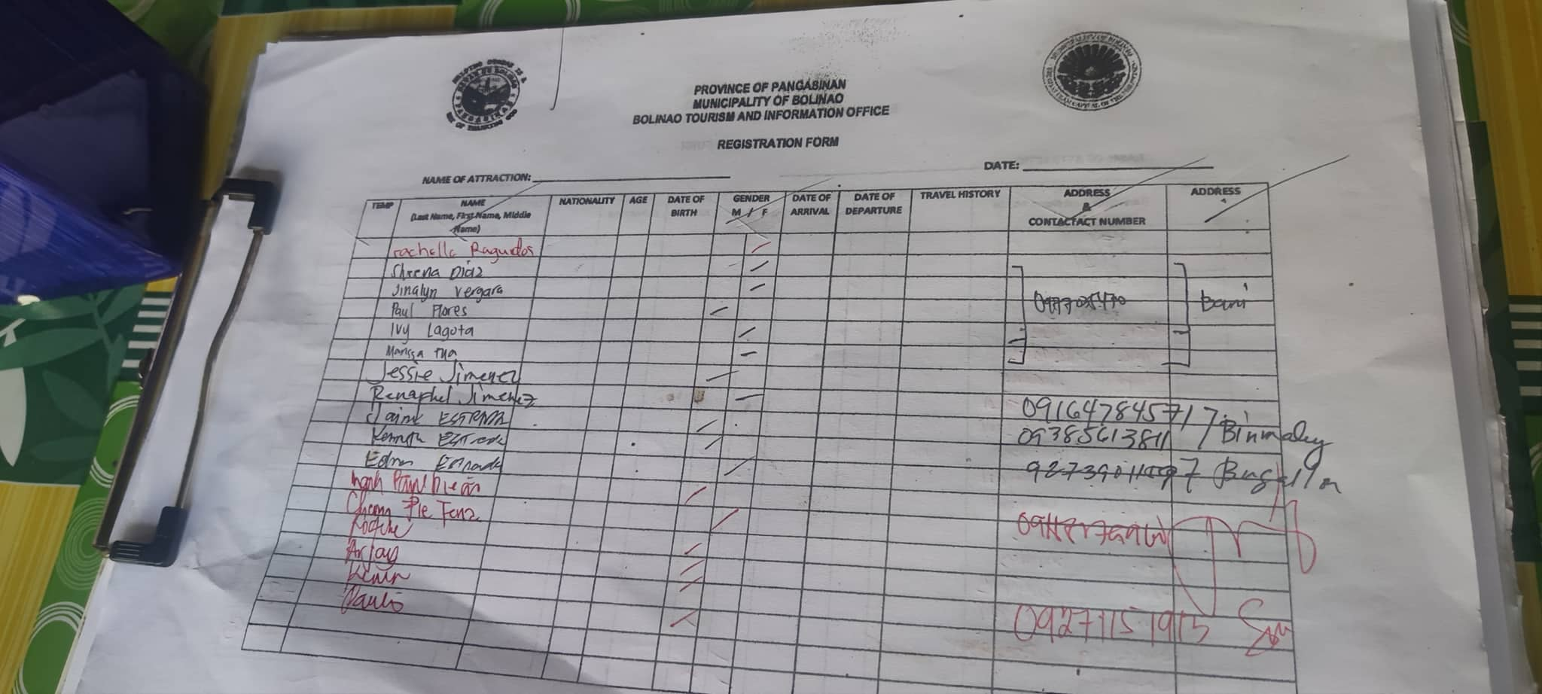

An example of registration form captured to a certain tourist site in Bolinao, Pangasinan.

**Data Requested from DOT – Annual Visitors of Bolinao**

A PDF document requested at DOT that presents the annually collected tourist visitations in the Municipality of Bolinao.

**Sprint I – Live Map**

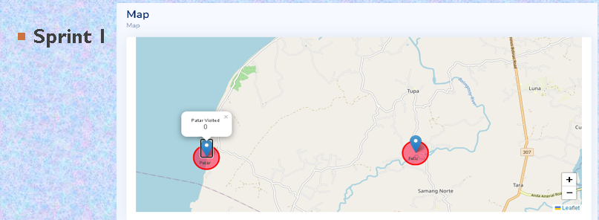

The first sprint consisting of simple UI Live Map of the system.

**Sprint II – Live Map Improvement**

The second sprint where live map was improved based on the feedback of the Product Owner.

**Sprint I – Add Map**

Initial Sprint in adding new pins on the live map.

**Sprint II – Add Map**

Adding new pins/location in the live map was improved in the second sprint.

**Trello Board**

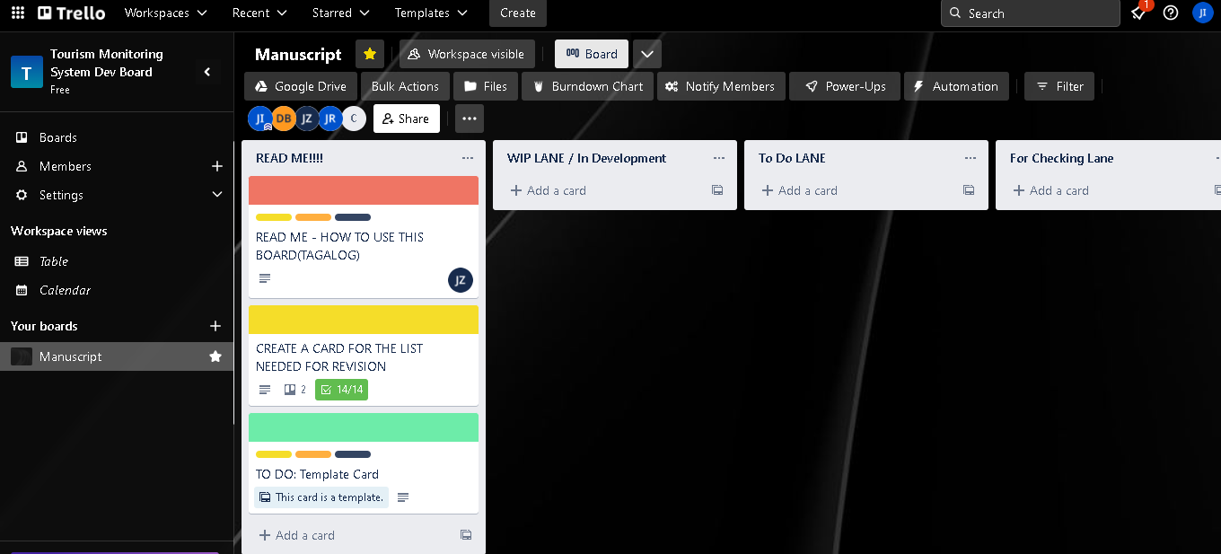

Tourism Monitoring System Dev Board where product backlogs were listed.

**GitHub System Repository – Initial Commit**

Creation of GitHub repository of the system including its initial commit.

**GitHub System Repository – Bug-fixes**

Bug-fixes in the system based on the sprint backlogs.

Appendix M

**Certificate of Grammar Check**

**SOON**